**Introduction to Execution**

**Execution**

Execution is the workspace where a user **can create and execute Suites**(collection of modules and scripts).

Navigation for Execution

FireFlink > Left Navigation Panel > Execution

**Suite**

The suite is a **collection of modules, sub-modules, and scripts**. Suites are created to test a behavior or set of behaviors of an application.

**Navigation for Suite**

Fireflink > Left Navigation Panel > Execution > Suite

Two types of suites can be created

* Automation Suite.
* Manual suite.

Pre-requisites for Suite

* Suite Type should be selected.
* Modules should be created.
* scripts should be created.

Creating Suite

* Click on the “**+ Suite**” button in the Suites table.

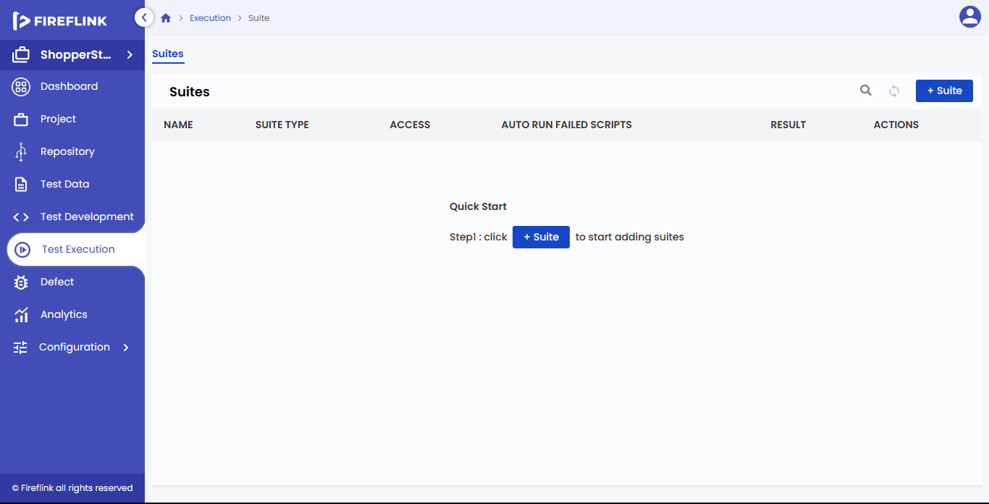

* Create Suite page will be displayed.

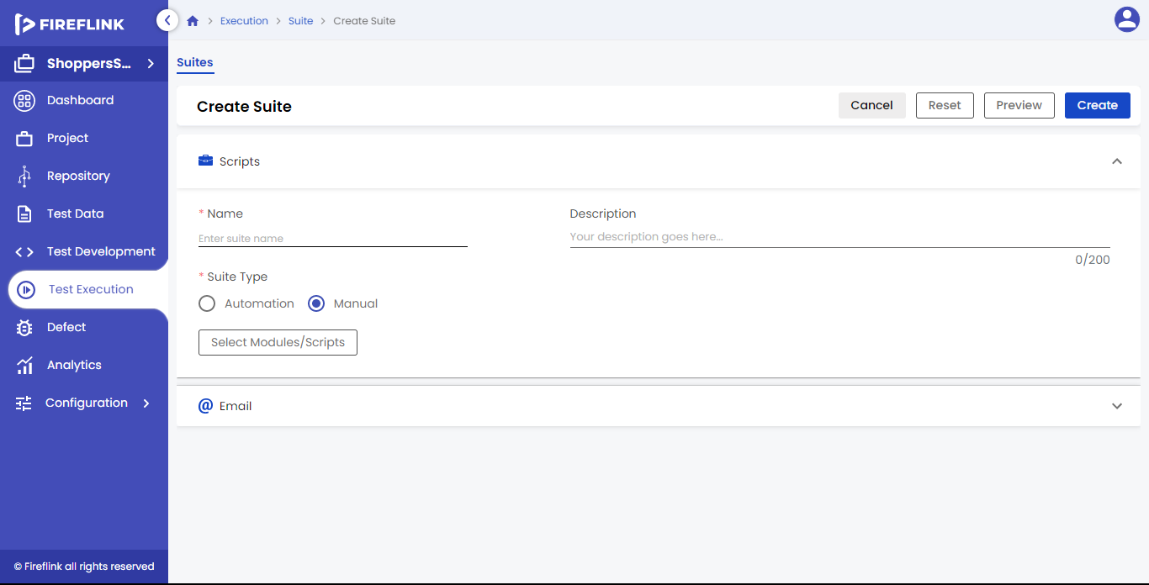

* Enter the data to all mandatory fields, for example, the Name Text field.
* Select the suite type, i.e. automation or manual.
* Select the Modules/Scripts by clicking the Select button in the Select Modules/Scripts popup.

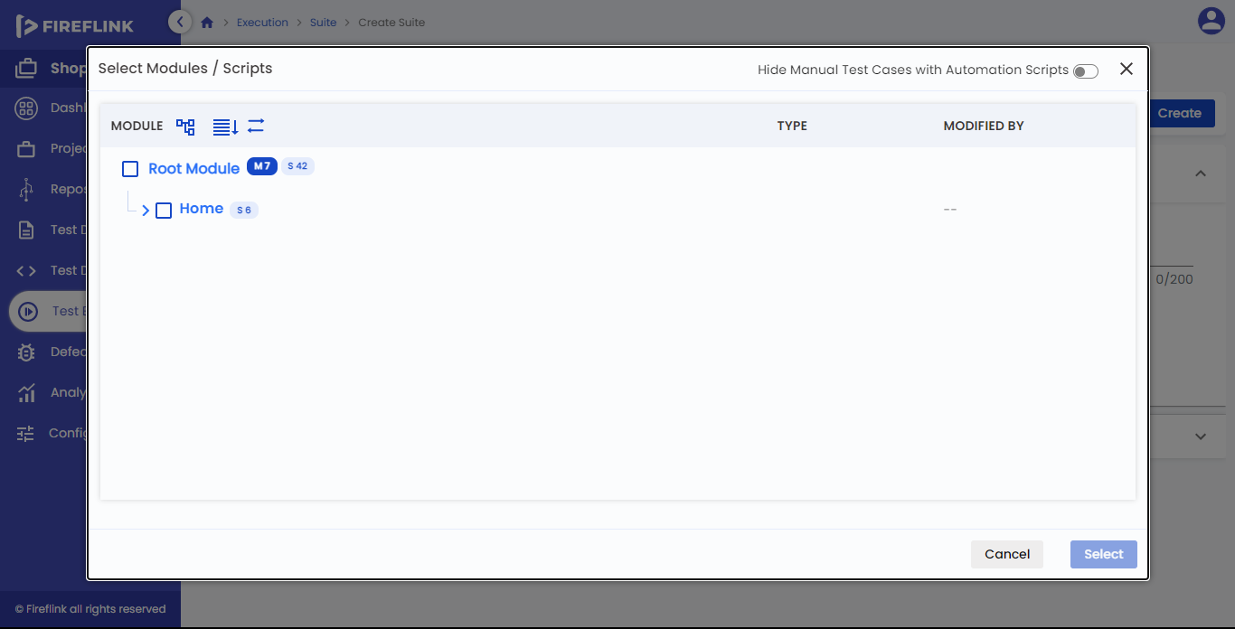

* Select the variables
* For the Project Environment variable

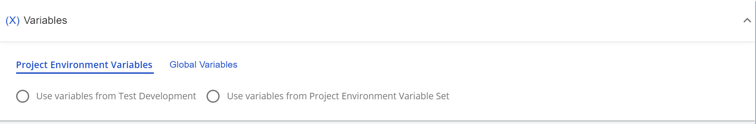

* for Global variables

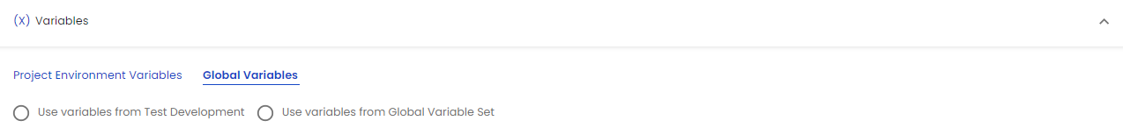

* for test Data

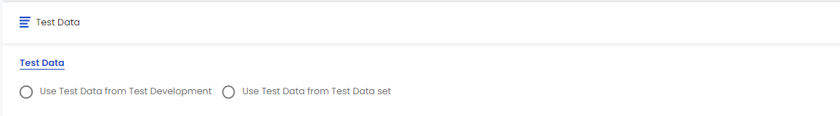

* Select the Email groups and type of email reports to send.
* Click on the Create button.
* **Note:** when the user clicks on the manual, variable and test data will not be available

**Columns under Suites Table**:

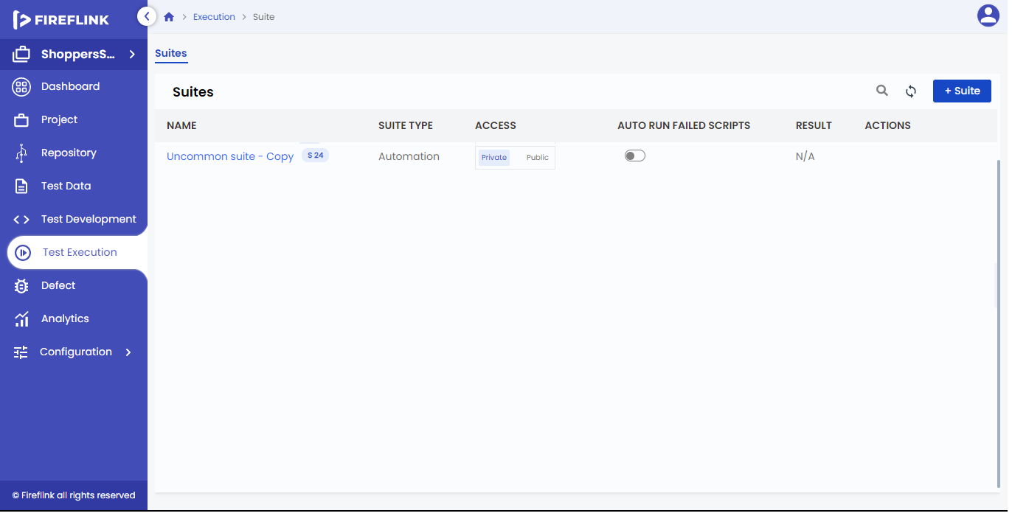

* **Name**
* Under this column, the suite name is displayed.
* The suite name is clickable. Upon clicking on any of the suite names, the user is redirected to the suite details page.
* **Suite Type**
* Under this column suite type is displayed.
* **Access**
  + Under this column, the Access Switch buttons are displayed. Users can choose “Private” or “Public” in that column.
  + By default, the “Private” option is selected.
  + If the “Private” option is selected for a particular suite, then it will be displayed only for the user who has created that particular suite.
  + If the “Public” option is selected then, it will be visible to all the users.
* **AutoRun Failed Scripts**
  + Under this column, the auto-run failed scripts toggle button will be displayed in every row. In-suite if we need to trigger only failed scripts automatically after the execution we need to turn on the toggle button.
* **Result**
  + Under this column, the status is displayed for a particular suite and it is clickable.
  + The latest execution status, of a particular suite is displayed.
  + Upon clicking on a particular suite’s status, the user is navigated to the result on the page of that suite.
* **Actions**
  + On hovering the mouse on any su,ite “Run”, “Edit”, “Impact List” and “More” icons are displayed under this column.

How to See Suite Results?

* On the Click of “status” that is present under the Result column, the user will navigate to the results page as shown on the below screen.

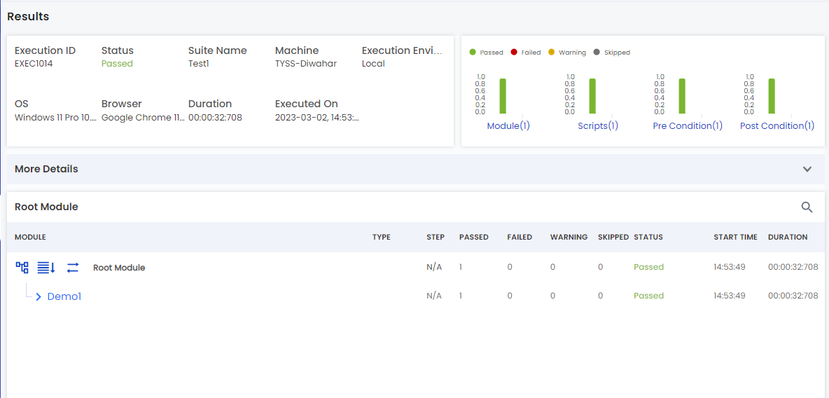

* Also upon clicking on-suite name that is present under the name column, you will navigate to the details page, then you can click on the execution dashboard tab as shown in the below screen.

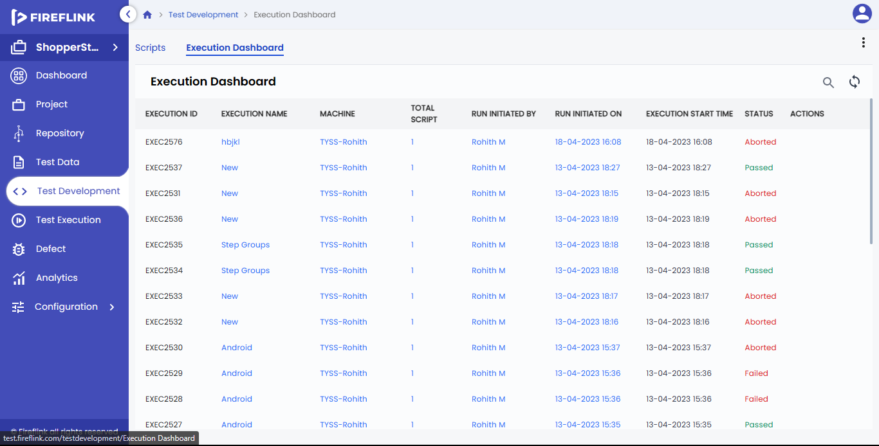

* In the execution>>dashboard table click on particular suite instance status to see the result of the suite.

**Trigger only the failed Scripts automatically in the suite.**

* Click on the auto-run failed scripts toggle button in the Suites table to trigger failed scripts automatically.

**Edit a Suite**

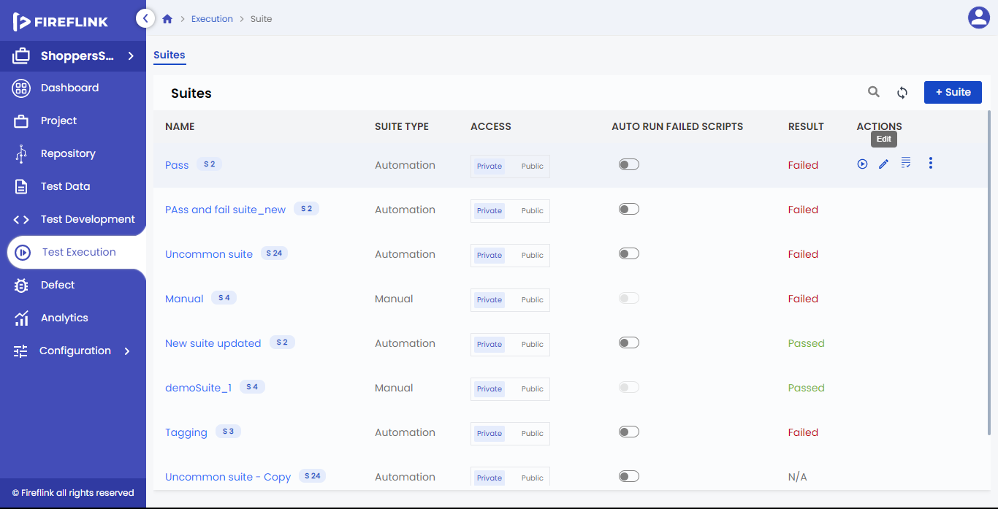

* On hovering the mouse on a suite name that you need to Edit under the Action column you can see the Edit icon.
* Click on the Edit icon.
* A page with “Edit Suite” is displayed.
* Do the necessary changes.
* User can edit Name, Description, Variable, Test data
* Click on the Update button to save the changes.

**Delete a Suite**

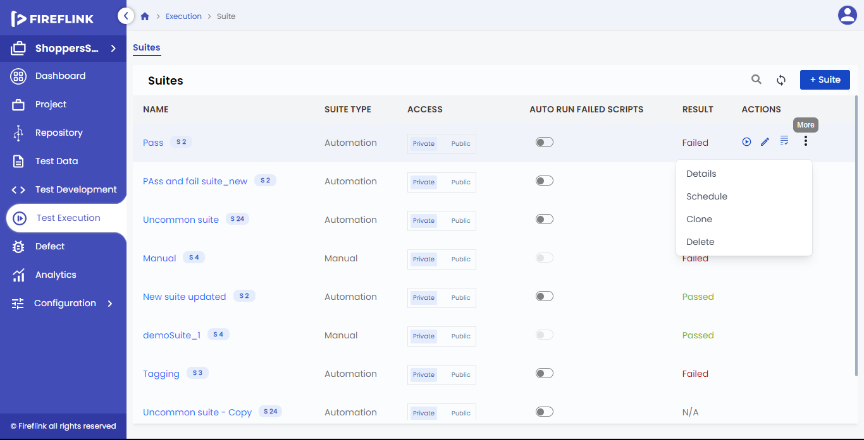

* On hovering the mouse on a suite name that you need to Delete and you can see the More icon.
* Click on more icons. Options drop-down is displayed.
* Click on the “**Delete**” option.
* A warning popup will be prompted.
* Click on the “Delete” button to delete the suite permanently.

**Note**: -

Based on Impact, the user is allowed to delete the Suite.

**Suite Creation**

* Upon clicking on the “**+ Suite**” button in the suites table, it will load the create suite page in the same tab, and the contents of that page are explained below.

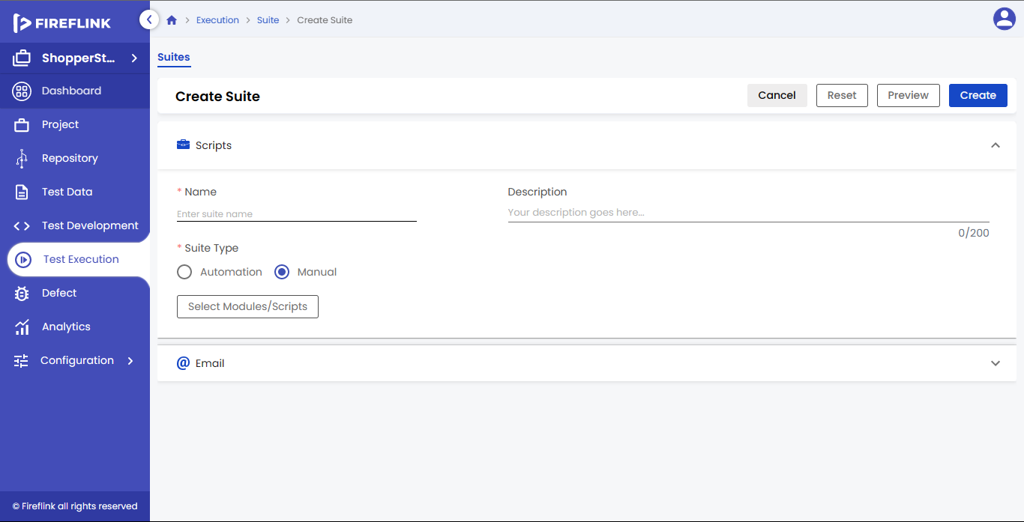

**Manual Suite Creation**

* **Name**: -
* It is a mandatory field. You can provide the Name of the suite in this field.
* **Description**: -
* The user can describe the suite in this field with a character limit of 200. This is a non-mandatory field.
* **Suite type**: -
* By default, the manual radio button is selected.

**Columns under Modules/Scripts Table**

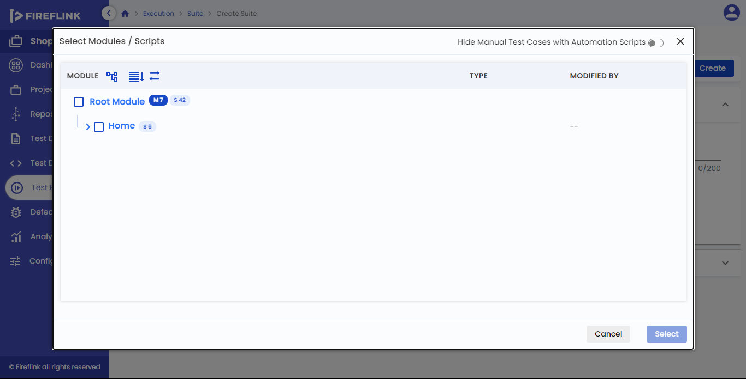

* **Module**
  + Under this column, the Module Tree structure is displayed.
  + The Module Tree structure includes all the Modules, Sub-Modules, Scripts, and Pre-Post conditions.
  + For Sub-Modules, the Script count is the total number of scripts present in the sub-module.
  + For Modules, the Script count is the number of scripts present in the Module and the number of scripts present in the Sub-Module.
  + The number of modules counts and the Scripts count for root modules is the total number of modules and scripts present (selected) in that particular suite.
* **Type**
* Under this column, the Script type is displayed.
  + For Root Module, Module, and Sub-Module Type columns should be empty.
  + The Script Type can be ‘WEB’, ‘WEB SERVICES’, or ‘DATABASE’ for the ‘WEB’ Project type.
  + The Script Type can be ‘ANDROID’, ‘WEB SERVICES’, or ‘DATABASE’ for the ‘MOBILE’ Project type and ‘ANDROID’ Platform type.
  + The Script Type can be ‘ANDROID’, ‘iOS’, ‘WEB SERVICES’, or ‘DATABASE’ for the ‘MOBILE’ Project type and ‘ANDROID’ and ‘iOS’ Platform type.
  + The Script Type can be ‘WEB SERVICES’, or ‘DATABASE’ for the ‘WEB SERVICE’ Project type
* **Modified By**
  + Under this column, “Modified By” details are displayed.
  + “Modified By” implies the user name who has modified modules, sub-modules, and Scripts the latest, and it is displayed only for modules, sub-modules, and scripts.
* **Hide Automation Scripts with Manual Test Cases**
  + This toggle button is used to filter scripts with manual test cases.
  + If the user turns on the toggle button, it enables the test cases with an automation script.
  + If the user turns off the toggle button, it disables the test case with automation and manual steps.

**How to Select Modules/ Scripts?**

* Click on the “Select Modules/Scripts” button in the Modules /Scripts table.
* Select the “Modules/Scripts” popup will be prompted.
* Select required modules, Sub-modules, and scripts in the module table by clicking on checkboxes.
* After module selection, the “Select” button will turn into an enabled state.
* Click on the “Select” button.

Select Modules/Scripts popup

Module table

Columns under Module Table are: -

* **Module**
  + Under this column, the Module Tree structure is displayed.
  + The Module Tree structure includes all the Modules, Sub-Modules, Scripts, Pre-Post conditions, and Root Modules.
  + Users should select the checkboxes to select Module, Sub-Module, or Script.
  + The number of scripts counted for sub-modules will be the total number of scripts present in the sub-module.
  + The number of Scripts counts for modules will be the number of scripts present in the module and the number of scripts present in the submodule.
  + The number of Modules or Scripts count for root modules will be the total number of modules and scripts present in the module table.
* **Type**
  + Under this column, the Script type is displayed.
  + For the Root Module, Module and Sub-Module Type columns will be empty.
* **Modified By**
  + this column “Modified By” details are displayed.
  + “Modified By” implies the user name who has modified modules, sub-modules, and Scripts and one who modify, at last, those user details will be displayed only for modules, sub-modules, and scripts.

**Email**

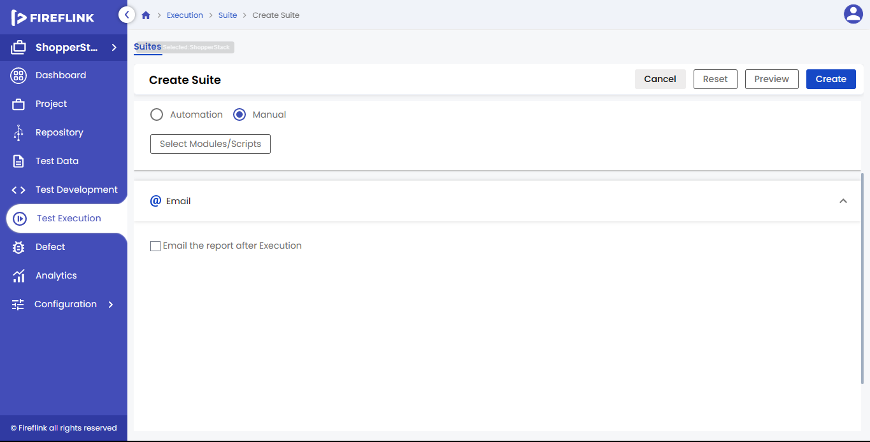

In the Email section, users can send an email notification after the execution by selecting the email group or entering the email id. Email is not mandatory, but if the user selects the checkbox then at least one email should be added.

Why do we need Email?

* To send email notifications on-suite execution starts.
* To send email notifications on-suite execution completion/termination.

Pre-requisites for Email

* Users should select the “Email the report after Execution” check box in the email section.
* Users should create email groups in email configuration.

The email consisted of two tabs in a row, they are: -

* Email Recipients tab
* Email Reports tab

**Note**: -

By default, the “Email Recipients” tab will be selected.

**a. Email Recipients Tab**

Inside the email recipients tab, two fields would appear one after the other in a single row below the tab.

* Recipient group: It is a mandatory field, here when we enter an email group name or when we click on this field, it will display email groups with a check box in the dropdown which we created in the email configuration. After selecting the checkbox, click on the “Add” button, and email group details will be displayed in the “Email Recipients” table.
* Recipient Email Id: It is a mandatory field, here we can add an email id that is not present in the email group. After entering the email id, we should click the “Enter” key, after that, we should click on the “Add” button to display the email id in the “Email Recipients” table.
* Email Recipients Table: “Email Recipients” table is present below the Recipient group field. The table columns are explained below:
  + Email Id: This column displays the email id which we added from the recipient group or the recipient email id filed.
  + Recipient Name: This column displays the recipient name which is associated with the email id.
  + Recipients Group: This column displays the recipient group name which is associated with the email id.

**Note**:  
1. User can search the email id by clicking on the search icon that is present in the “Email Recipients” table.  
2. Users can expand the email recipients table by clicking on the “Expand” icon that is present in the “Email Recipients” table.

**b. Email Reports Tab**

In the Email Reports tab, we had two sections, they are: -

* Email Notifications: In this section, we had two checkboxes, they are: -
  + On Suite Execution Start: Whenever execution starts, email recipients will get an email notification about the execution start.
  + On Suite Execution Completion /Termination: Whenever execution is Completed/Terminated, email recipients will get an email notification about execution Completion/Termination.
* Attach Execution Report: In this section, we had three checkboxes, they are: -
  + PDF: When the user selects the “PDF” check box, the User will get the report in PDF format, which will attach to the email.
  + Click on the “Create” button to create the suite.

**Automation Suite Creation**

* Name: It is a mandatory field. You can provide the Name of the suite in this field.
* Description: The user can describe the suite in this field with a character limit of 200. This is a non-mandatory field.
* Suite type: The automation radio button is selected

**Columns under Modules/Scripts Table**

* Module: - As mentioned above in the manual suite creation it follows the same.
* Type: - As mentioned above in the manual suite creation it follows the same.
* Modified By: - As mentioned above in the manual suite creation it follows the same.

How to Select Modules/ Scripts?

As mentioned above in the manual suite creation it follows the same.

**Select Modules/Scripts popup**

Module table

Columns under Module Table are: -

* Module: - As mentioned above in the manual suite creation it follows the same.
* Type: - As mentioned above in the manual suite creation it follows the same.
* Modified By: - As mentioned above in the manual suite creation it follows the same.

**2. Variables**

Variables are the elements that are used to store the data to be referenced and used by programs and that can take different values.

Why do we need Variables?

* With the help of variables, you can avoid hard-coding the program.
* It avoids the re-work when the value changes.
* To reuse the values at multiple places.

Pre-requisites for Suite

* Modules/Scripts should have been published in Test Development.
* Modules/Scripts should be selected for a suite.
* Based on the selection of Modules/Scripts related variables are displayed.

**Types of Variables**

1. Project Environment Variables.

2. Global Variables.

**Now look into in detail Variables**

1. Project Environment Variables

A project Environment Variable is a variable with a project scope. Only that project created and the modules, sub-modules, can access the variables and scripts present under it.

**Why we need Project Environment Variables**

* With the help of Project Environment Variables, you can avoid hardcoding the values.
* Single-time declaration of Project Environment variables is enough outside the Project.
* It is useful when multiple functions are accessing the same data.
* It avoids a lot of re-work when value changes.

**Project Environment Variables contain two radio buttons. They are**-

* Use Variables from Test Development.
* Use Variables from Project Environment Variable Set.
  1. **Use Variables from Test Development**

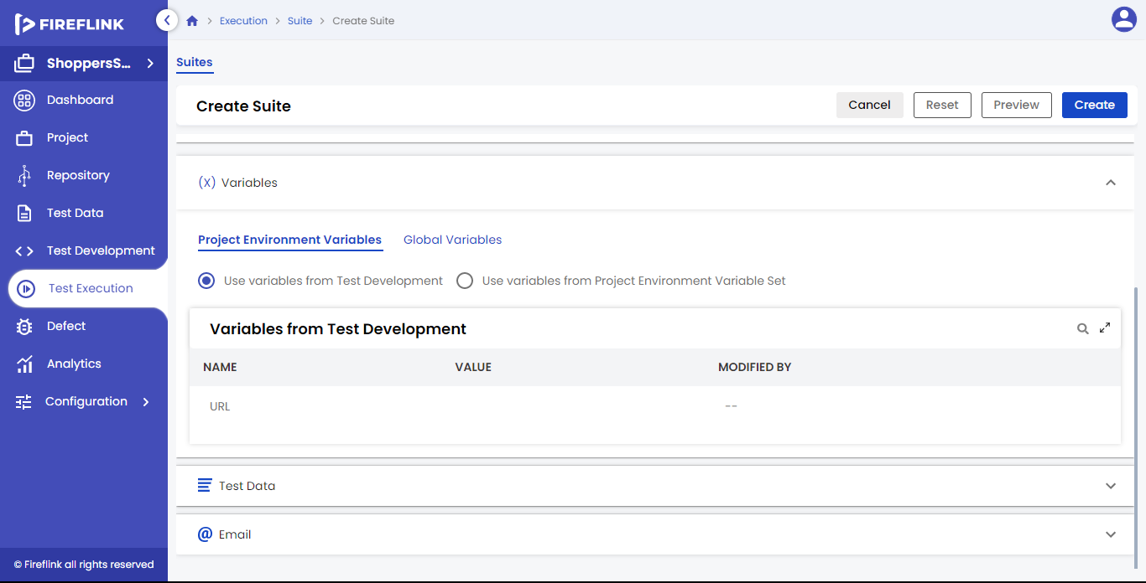

If the user selects this radio button, all variables that are part of selected modules and scripts will be used with the latest published state.

**Columns under Variables from Test Development Table**:

* **Name:** -
* Under this column, all Variables names part of selected modules and scripts are displayed.
* **Value:** -
* Under this column, values for the Variables are displayed.
* **Modified By: -**
  + Under this column, modified details are displayed.
  + In this column, modified-by implies the user name who has modified the latest Variable value.

**1.2 Use Variables from Project Environment Variable Set**

If the user selects this radio button, Variables that are part of selected modules and scripts will be used with selecting created set values.

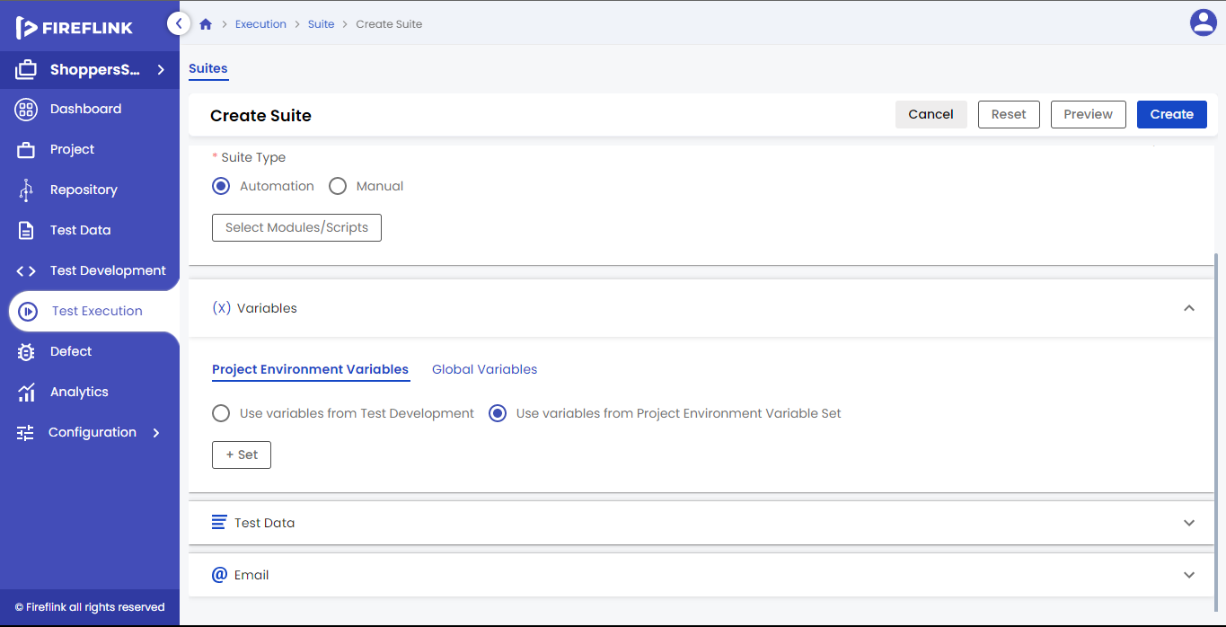

**Columns under Variables from Test Development Table:**

* **Select Set:** This column displays radio buttons for variables set. For selecting the set, the user should select the radio button which is present in this column.
* **Variable Set:** This column displays Variables set names. Here, the variable set name is clickable. Upon clicking on the variable set name, the user can navigate to the variable set details popup.
* **Last Sync:** This column displays the Last Sync details for the Variable set. The last sync details will be displayed in this column only when all variable values are synced in that particular set, otherwise, it displays NA.
* **Modified By:** This column displays modified-by details for variable sets. Here, modified-by implies the username who has modified the variables set the latest. Here, the modified column is clickable. Upon clicking, the user will be navigated to the user details popup.
* **Actions**: Under this column “Edit” and “Delete” icons are displayed on mouse hover on Variable Set.

**Create Project Environment Variables Sets:**

* Click on the “+ Set” button in the Project Environment Variables Sets table.
* Create Project Environment Variables Sets popup is prompted.
* Enter the data in all mandatory fields. For example, the Name Text field.
* Users can edit the project environment variable value by clicking on a particular value in the Value column.
* Click on the Create button.

**Create Project Environment Variables Set pop-up:**

* **Name:** -

Provide the Name of the Variable set in this field. It is a mandatory field.

The Project Environment Variables table is displayed below the name text field.

Columns under the Project Environment Variables Table are: –

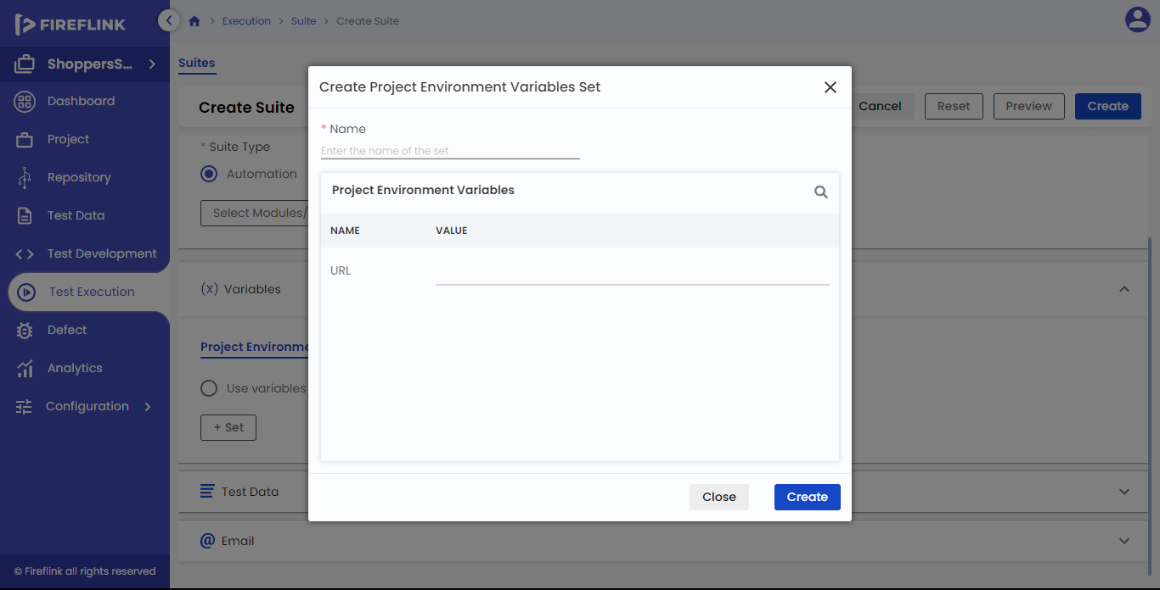

* **Name**:
  + Under this column, all Variables names part of selected modules and scripts is displayed.
* **Value**:
  + Under this column, the values for the Variables are displayed.
  + Users can edit the values under the value text field.

**Note**: All project environment variables are not visible in the table. The user can see those variables by scrolling down using the scroll bar in the project environment variables table.

* When a user clicks the “Close” button, the “Create Project Environment Variables Set” popup is closed without creating any variable set.
* When a user clicks the “Create” button, the “Create Project Environment Variables Set” popup is closed by creating the variable set. The created variable set will be displayed in the “Project Environment Variables Sets” table (Refer above screen).

**Note**: When there are no Variables sets present in the table, the Full-Screen Icon will be in disabled mode.

Edit the Project Environment Variables Set

* On hovering the mouse on a Variable Set name that you need to Edit, under the action column you can see the Edit icon.
* Click on the Edit icon.
* Edit Project Environment Variables Set pop-up is prompted.
* Click on the Value which you want to edit.
* Click on the Update button.

Variable Set Details Popup

* Click on the particular Variable Set name that is present in the variable set column to see the details in the popup.
* Click on the close button to close the variable set details popup.
* Click on the search icon present in the Sets table to search the variables.
* Click on the forward icon to change the Variables page in the Sets table.

**Edit Project Environment Variables Set**: -

* The project Environment Variable Set table is displayed below the popup header. Columns under the Project Environment Variable Set Name Table are: -

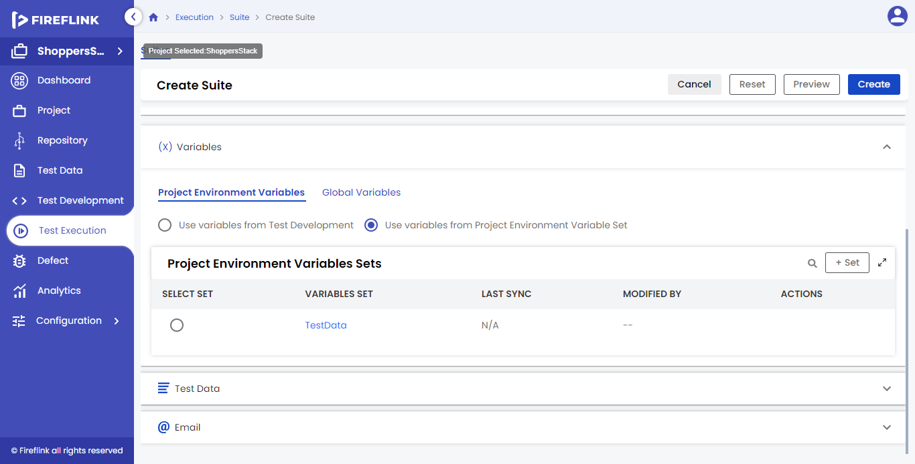

* Check box: Under this column, the check box for variables is displayed. The user should select the checkbox to sync the variables.
* Name: Under this column, all the Variables names part of the selected Project Environment Variable Set are displayed.
* Value: Under this column, Variable values are displayed. The user should click the value to edit the value.
* Last Sync: Under this column, Last Sync details for Variables are displayed. Here, the last sync details will be displayed, only when variable values are synced, otherwise, it displays NA.

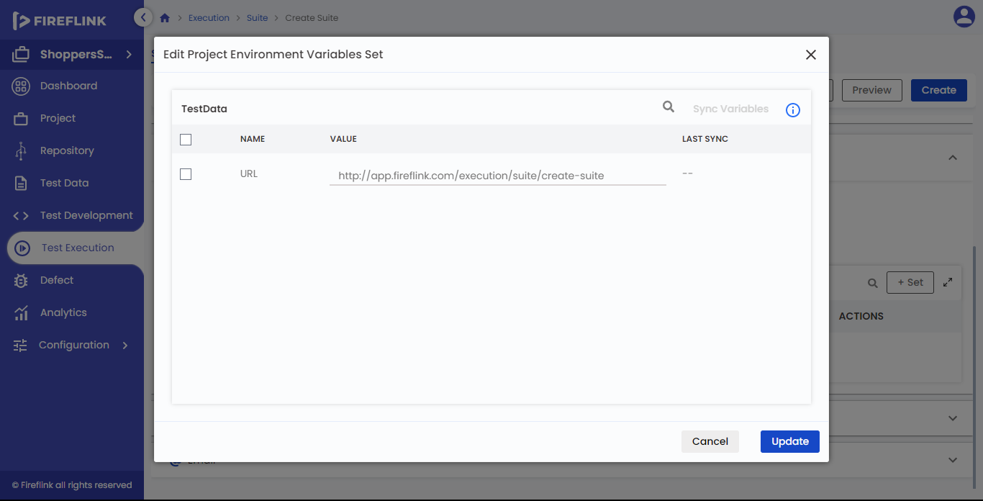

* When the user clicks the “Close” button **“Edit Project Environment Variables set”** popup is closed and the user will navigate back to the **“Project Environment Variables set”** table.

How do sync variables in the existing Set?

* Click on the edit icon particular set which one you want to sync.
* Select the variables by clicking on the check box after that **“Sync Variables”** button will turn into an enabled state.
* Click on the **“Sync Variables”** button.
* Click on the **“Update”** button.

When the user clicks on the **“Update”** button, edited values and synced variables are updated to the project environment variable set.

Delete the Project Environment Variables Set

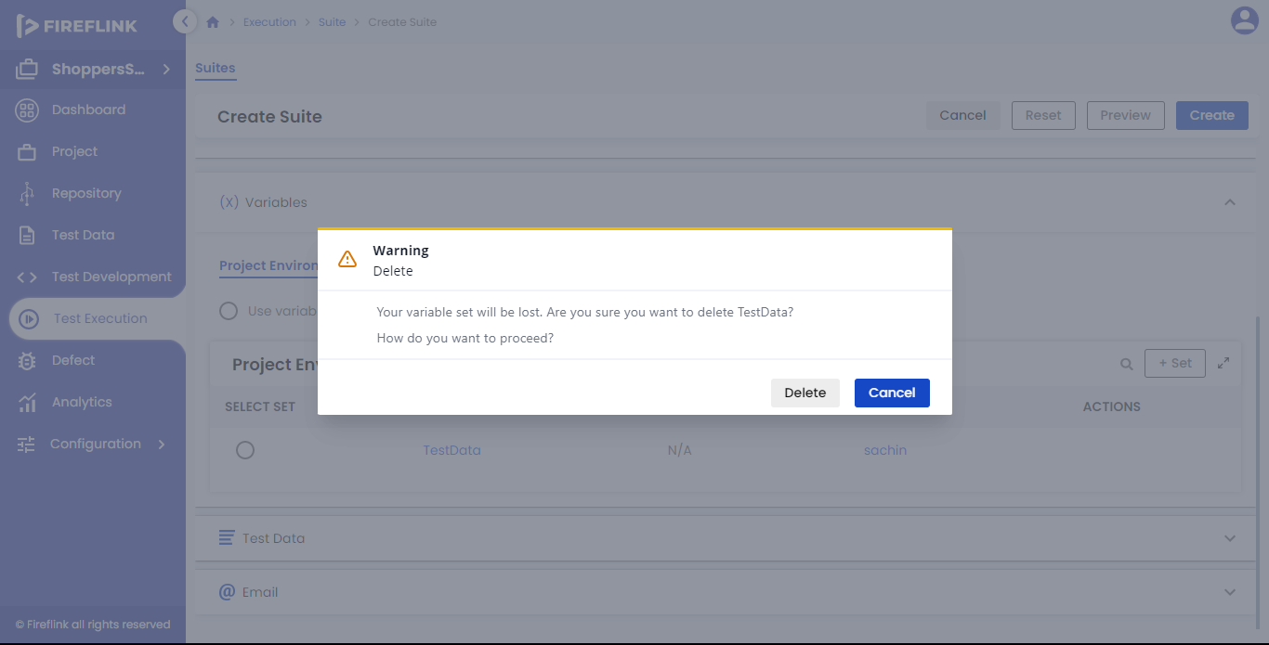

* Mouse hover on a Variable Set name that you need to Delete.
* Click on the **“Delete”** icon.
* A warning popup is prompted.
* Click on the **“Delete”** button.

**Note:** -

Based on Impact, the user is allowed to delete the Variable Set.

**2.** **Global Variables**

A global variable is a variable with global scope and whose value is declared outside the program. Here data sharing is possible as multiple programs can access the same global Variable.

Why do we need Global Variables?

* With the help of Global Variables, users can avoid hard-coding the program.
* Single-time Declaration of global variables is enough outside the modules.
* It is useful when multiple functions are accessing the same data.

Global Variables contain two radio buttons. They are: -

* Use Variables from Test Development.
* Use Variables from the Global Variables Set.

**2.1 Use Variables from Test Development**

If the user selects this radio button, all variables that are part of selected modules and scripts will be used with the latest published state.

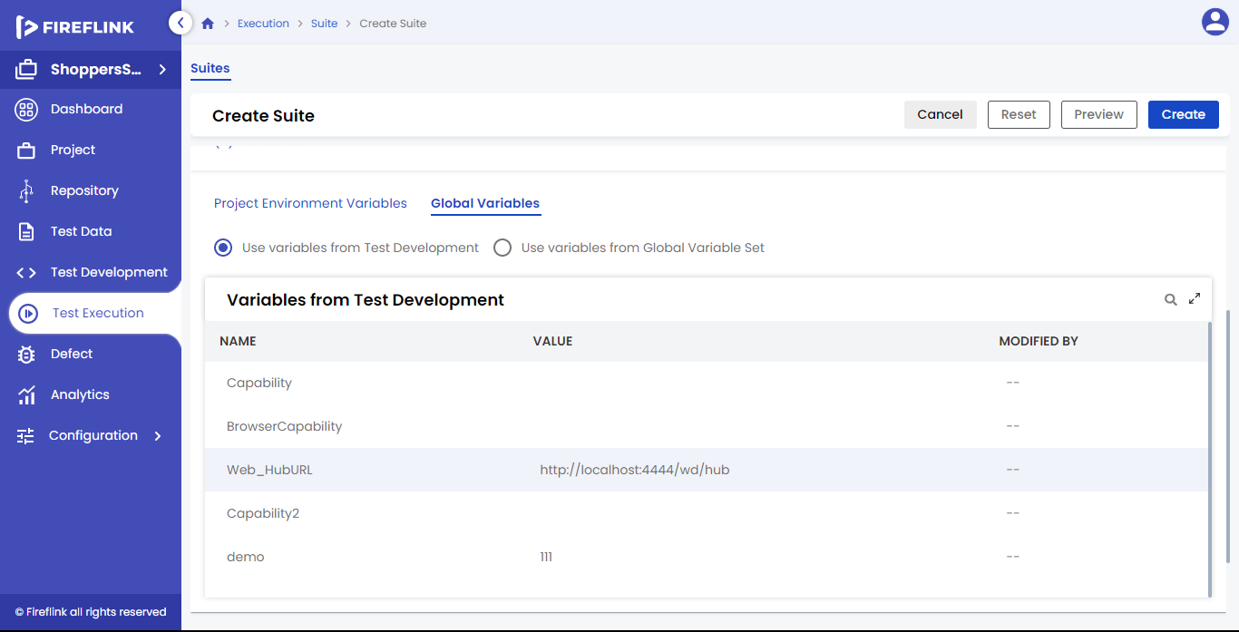

Columns under Variables from Test Development Table:

* Name:
  + Under this column, all the Variables names part of selected modules and scripts are displayed.
* Value:
  + Under this column, values for the Variables are displayed.
* Modified By:
  + Under this column, modified details are displayed.
  + In this column, modified-by implies the user name who has modified the latest Variable value.

2.2 **Use Variables from the Global Variables Set**

If the user selects this radio button, Variables that are part of selected modules and scripts are used with selecting created set values.

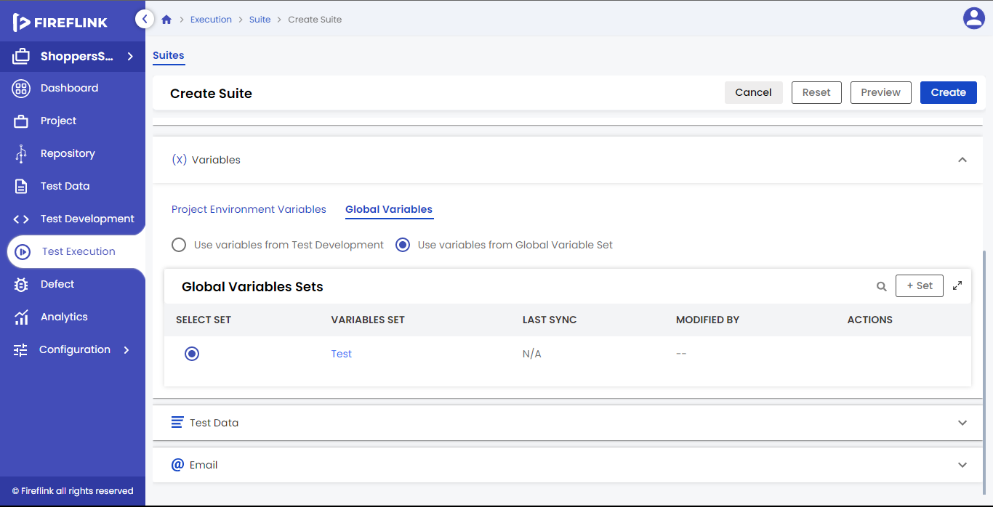

Columns under Variables from Test Development Table:

* **Select Set**: This column displays radio buttons for variables set. For selecting the set, the user should select the radio button that is there in this column.
* **Variable Set:** This column displays Variables set names. Here, the variable set name is clickable. Upon clicking on the variable set name, the user is navigated to the variable set details popup.
* **Last Sync:** This column displays the Last Sync details for the Variable set. Here, the last sync details are displayed in this column only when all variable values are synced in that particular set, otherwise, it displays NA.
* **Modified By:** This column displays modified-by details for variable sets. Here, modified-by implies the username who has modified the variables set the latest. Here, the modified-by column is clickable. Upon clicking, the user will be navigated to the user details popup.
* **Actions:** Under this column, “Edit” and “Delete” icons are displayed on mouse hover on Variable Set.

How to create Global Variables Sets?

* Click on the “+ Set” button in the Global Variables Sets table.
* Create Global Variables Sets popup will be prompted.
* Enter the data to all mandatory fields for example Name Text field.
* Users can edit the global variable value by clicking on a particular value in the Value column.
* Click on the Create button.

**Create Global Variables Set pop-up**:

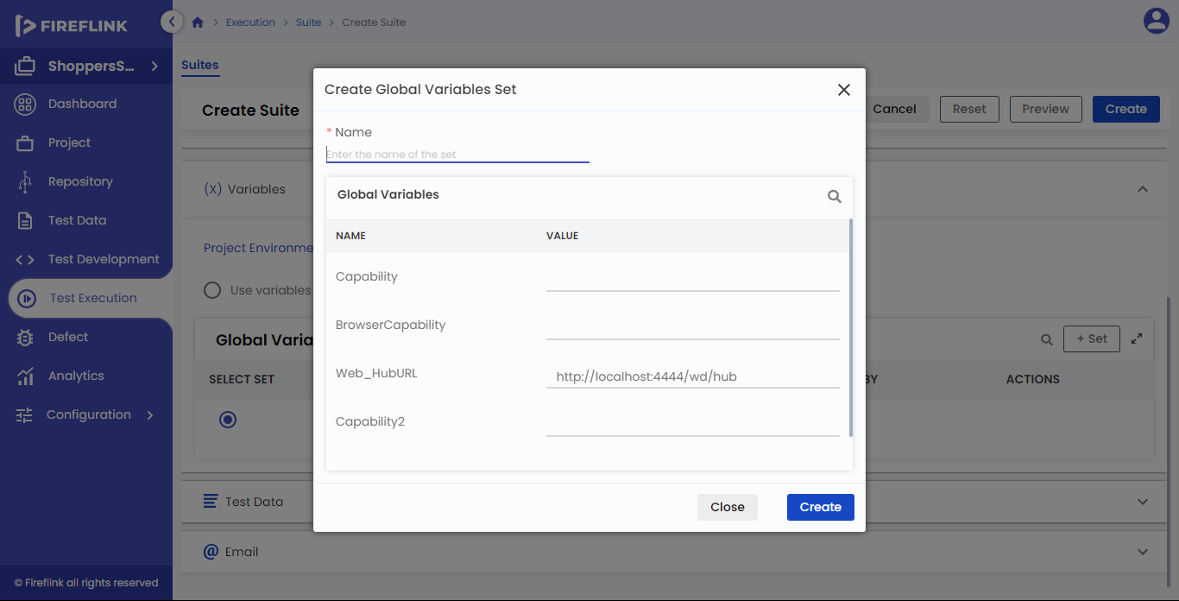

* Name: Provide the Name of the Variable set in this field. It is a mandatory field.

The Global Variables table is displayed below the name text field.

Columns under the Global Variables Table are: –

* Name:
  + Under this column, all Variables names part of selected modules and scripts are displayed.
* Value:
  + Under this column, values for the Variables are displayed.
  + Users can edit the values by clicking on the values.

Note: -

All Global variables are not visible in the table. Users can see those variables by down using the scroll bar in the Global variables table.

* When the user clicks the “Close” button, the “Create Global Variables Set” popup closes without creating any variable set.
* When the user clicks the “Create” button, the “Create Global Variables Set” popup is closed by creating the variable set. The created variable set is displayed in the “Global Variables Sets” table.

Note: -

When there are no Variables sets present in the table, the Full-Screen Icon is in disabled mode.

Edit the Global Variables Set

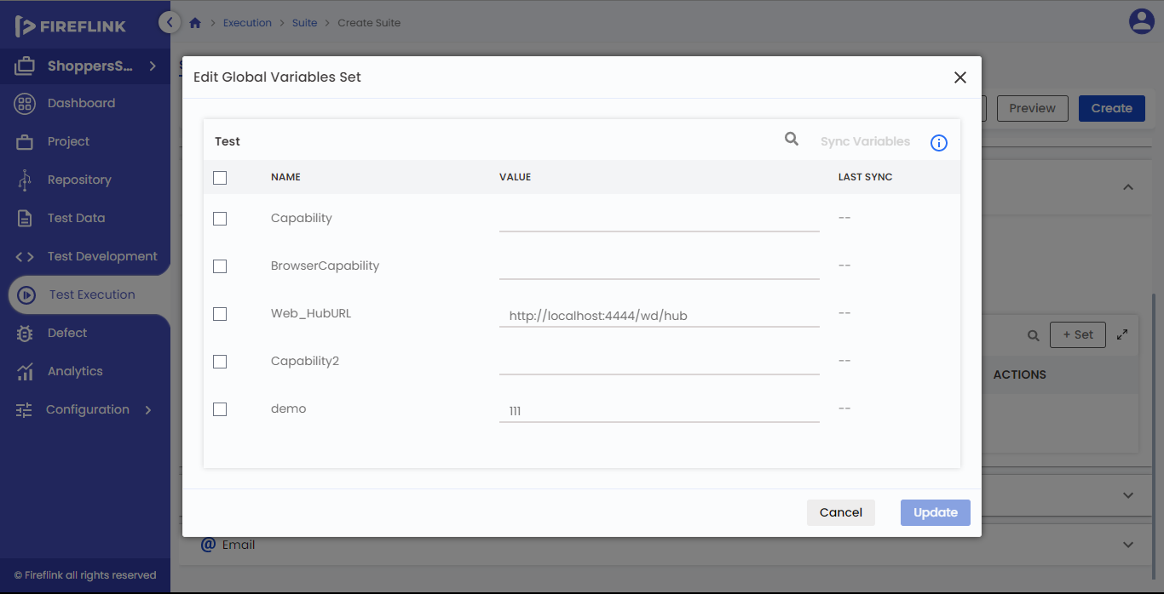

* Hover a mouse on a Variable Set name that you need to Edit.
* Click on the Edit icon.
* Edit Project Environment Variables Set pop-up will be prompted.
* Click on the Value that one wishes to edit.
* Click on the Update button.

**Variable Set Details Popup**

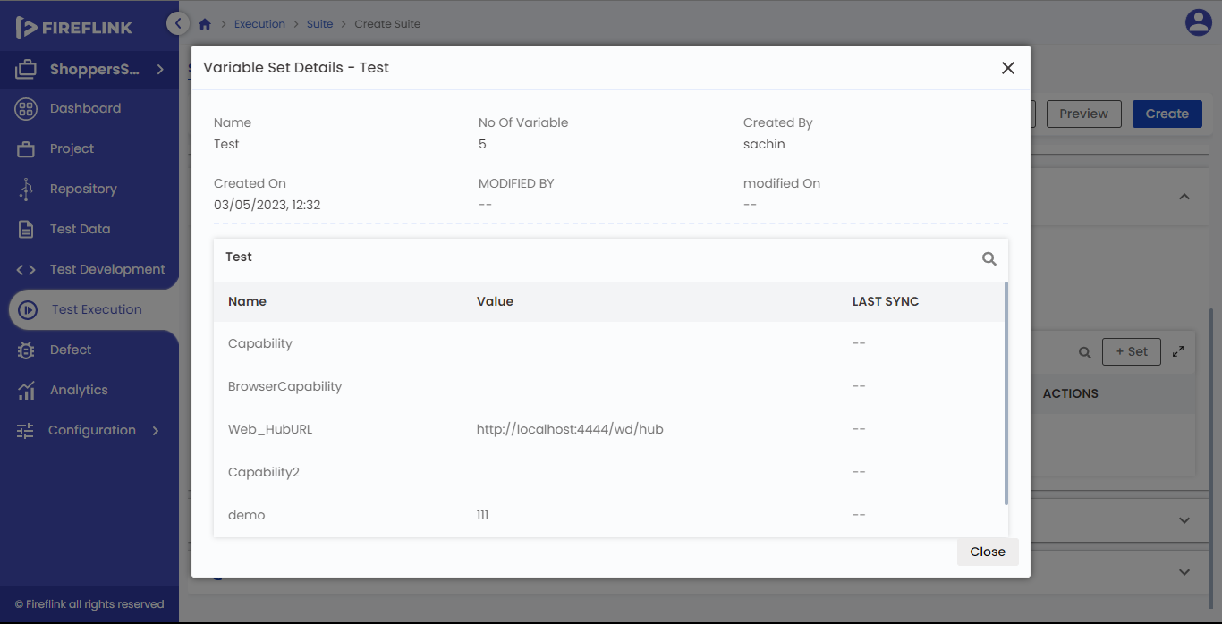

* Click on the particular Variable Set name that is present in the variable set column to see the details in the popup.
* Click on the close button to close the variable set details popup.
* Click on the forward icon in the pagination to change the Variables page in the Sets table.

Edit Global Variables Set Table

The Global Variable Set table is displayed below the popup header. Columns under Global Variable Set Name Table are: -

* Check box: Under this column, the check box for variables is displayed. The user should select the checkbox to sync the variables.
* Name: Under this column, all Variables names part of the selected Global Variable Set are displayed.
* Value: Under this column, Variable values are displayed. The user should click the value to edit the value.
* Last Sync: Under this column, the Last Sync details for Variables are displayed. Here, the last sync details will be displayed only when variable values are synced, otherwise, it displays NA.

How do sync variables in the existing Set?

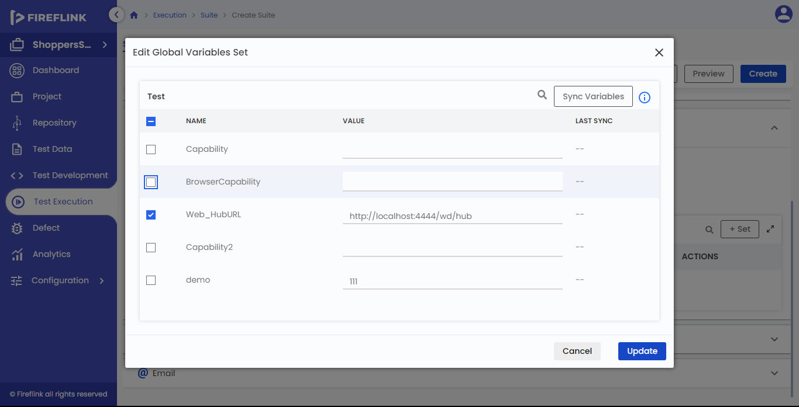

* Click on the edit icon particular set which one you want to sync.
* Select the variables by clicking on the check box after that “Sync Variables” button will turn into an enabled state.
* Click on the “Sync Variables” button.
* Click on the “Update” button.
* When the user clicks on the “Cancel” button, the “Edit Global Variables set” popup is closed and the user is navigated back to the “Global Variables set” table.
* When a user clicks on the “Update” button, edited values and synced variables are updated to the Global variable set.

How to Delete the Global Variables Set?

* Hover a mouse on a Variable Set name that you need to Delete.
* Click on the “Delete” icon.
* A warning popup is prompted.
* Click on the “Delete” button.  
  Note: Based on Impact, the user is allowed to delete the Variable Set.

**3. Test Data**

Test Data is nothing but the data that has been specifically identified for testing a particular piece of software.

Why do we need Test Data?

* To reuse the Test Data in multiple places.
* To avoid the re-work, when values change.
* Users can store huge data that is usually required for load testing or stress testing.

Test Data contains two radio buttons. They are:-

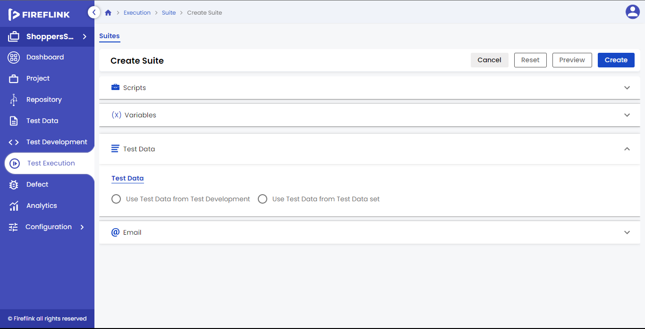

* Use Test Data from Test Development.
* Use Test Data from Test Data Set

**3.1 Use Test Data from Test Development**

If the user selects this radio button, all test data files that are part of selected modules and scripts are used with the latest published state.

Columns under Test Data from Test Development Table:-

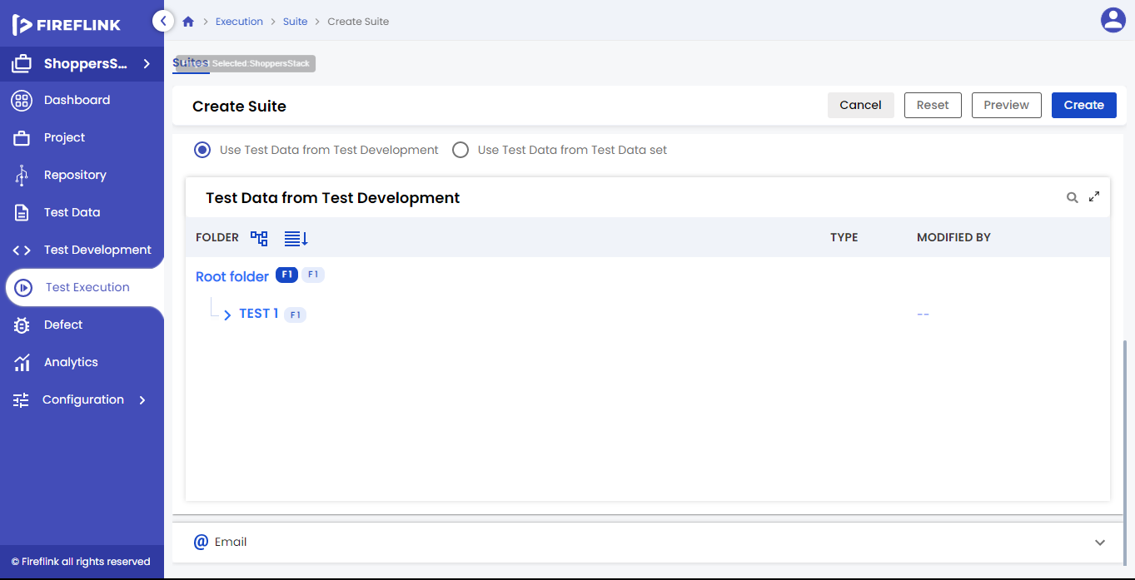

* **Folder:**
  + This column displays the Test Data folder, Sub Test Data folder, and Test Data files.
  + In the first row of the Folders column, the tree structure icon, and Scripts icon is displayed in front of the Root folder, and next to the Root Folder number of Folders and the number of Files count is displayed.
  + The number of files counted for the Sub-Test Data folder should be the total number of files present in the Sub-Test Data folder.
  + The number of files counted for the Test Data folder should be the total number of files present in the Test Data folder and the number of files present in the sub-test data folder.
  + The number of files and folders counted for the Root folder will be the total number of files and folders in the complete tree structure.
* **Type:**
  + Under this column, the Script type is displayed.
  + For the Root Module, Module, and Sub-Module Type columns should be empty. Only the Test Data Files Type column is displayed.
* **Modified By:**
  + This column displays modified-by details. Here, modified-by implies the username who modified the Test Data File last time. Here, the modified-by column is clickable. Upon clicking, the user will be navigated to the user details popup.  
    Note: The user can scroll the Test Data from the Test Development table by using the scroll bar.

**3.2 Use Test Data from Test Data Set**

If the user selects this radio button, test data files that are present in the project will be displayed.

Columns under Test Data from Test Data Table:

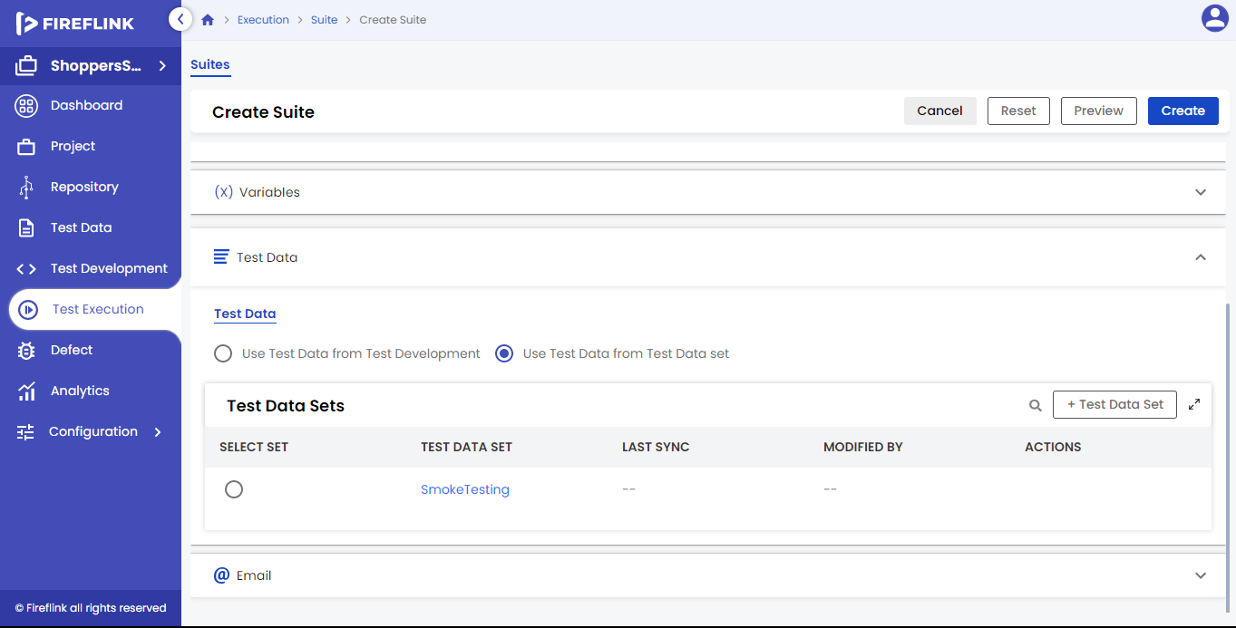

* Select Set: This column displays radio buttons for the Test Data set. For selecting the set, the user should select the radio button that is present in this column.
* Test Data Set: This column displays Test Data set names. Here, the Test Data set name is clickable. Upon clicking on the Test Data set name, the user is navigated to the Test Data set details popup.
* Last Sync: This column displays Last Sync details for the Test Data set. Here, the last sync details will be displayed in this column only when all Test Data values are synced in that particular set, otherwise, it displays NA.
* Modified By: This column displays modified details for Test Data sets. Here, modified-by implies the username who has modified the Test Data set to the latest. Here, the modified-by column is clickable. Upon clicking, the user will be navigated to the user details popup.
* Actions: Under this column “Edit” and “Delete” icons are displayed on mouse hover on Test Data Set.

How to create a Test Data Set?

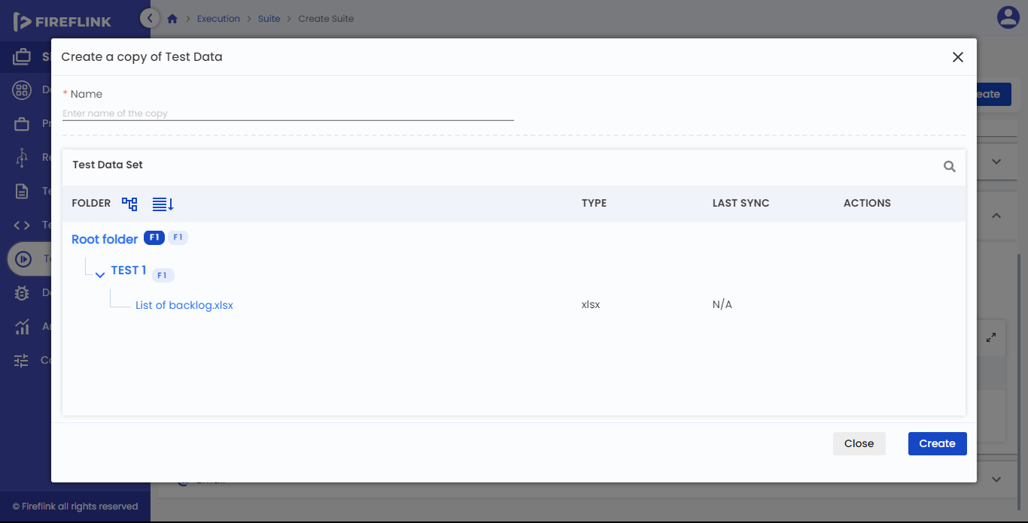

* Click on the “**+ Test Data Set**” button in the Test Data Sets table.
* Create a copy of the Test Data popup will be prompted.
* Enter the data to all the mandatory fields for example Name Text field.
* Users can download or replace the Test Data file by clicking on the**download or replacing**the icon.
* Click on the **Create** button.

Test Data Set Details popup:

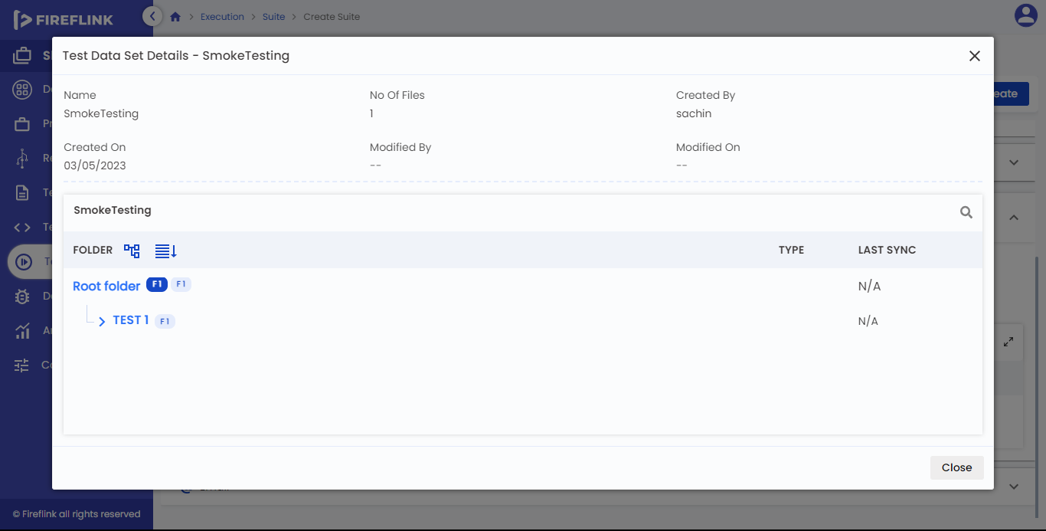

* Click on the particular Test Data Set name which is there in the Test Data Set column to see the details in the popup.
* Click on the close button to close the Test Data set details popup.

Create a Test Data Set popup

* **Name**:
  + Provide the Name of the Test Data set in this field. It is a mandatory field.
  + The Test Data Set table is displayed below the name text field. Columns

under the Test Data Set Table are: –

* **Folder:**
  + This column displays the Test Data folder, Sub Test Data folder, Test Data files, and Root Folder.
  + In the first row of the Folders column, the tree structure icon, and Scripts icon is displayed in front of the Root folder, and next to the Root Folder number of Folders and several File countries displayed.
  + The number of files counted for the Sub-Test Data folder should be the total number of files present in the Sub-Test Data folder.
  + The number of files counted for the Test Data folder should be the total number of files present in the Test Data folder and the number of files present in the subtest data folder.
  + The number of files and folders counted for the Root folder will be the total number of files and folders there in the complete tree structure.
* **Type:**
  + Under this column Test Data File type is displayed. Eg. xlsx, properties, pdf, XML, JSON, apk, IPA, CSV.
  + For the Root Folder, Test Data Folder, and Sub-Test Data Folder Type column should be empty. Only the Test Data Files Type column is displayed.
* **Last Sync:**
  + This column displays the Last Sync details for the Test Data set. Here, the last sync details are displayed in this column only when all Test Data values are synced in that particular set, otherwise, it displays NA.
* **Actions:**
  + Under this column, the “Download” and “Replace” icons are displayed on the mouse hover on the Test Data Set.
  + When the user clicks on the download icon, the test data file is downloaded to the local system.
  + When a user clicks on the Replace icon of a particular test data file, the user is navigated to the file explorer of the local system. Users should select the test data file in the local system. After selecting, click on the select button to replace the selected file with the existing one.
  + When a user clicks on the “Close” button, the “Create Test Data Set” popup is closed without creating any Test Data set.
  + When a user clicks the “Create” button, the “Create Test Data Set” popup is closed by creating a Test Data set. The created Test Data set is displayed in the “Test Data Sets” table.

Note: -

When there are no Test Data sets present in the table, the Full-Screen Icon is in disabled mode.

**Edit Test Data Set:**

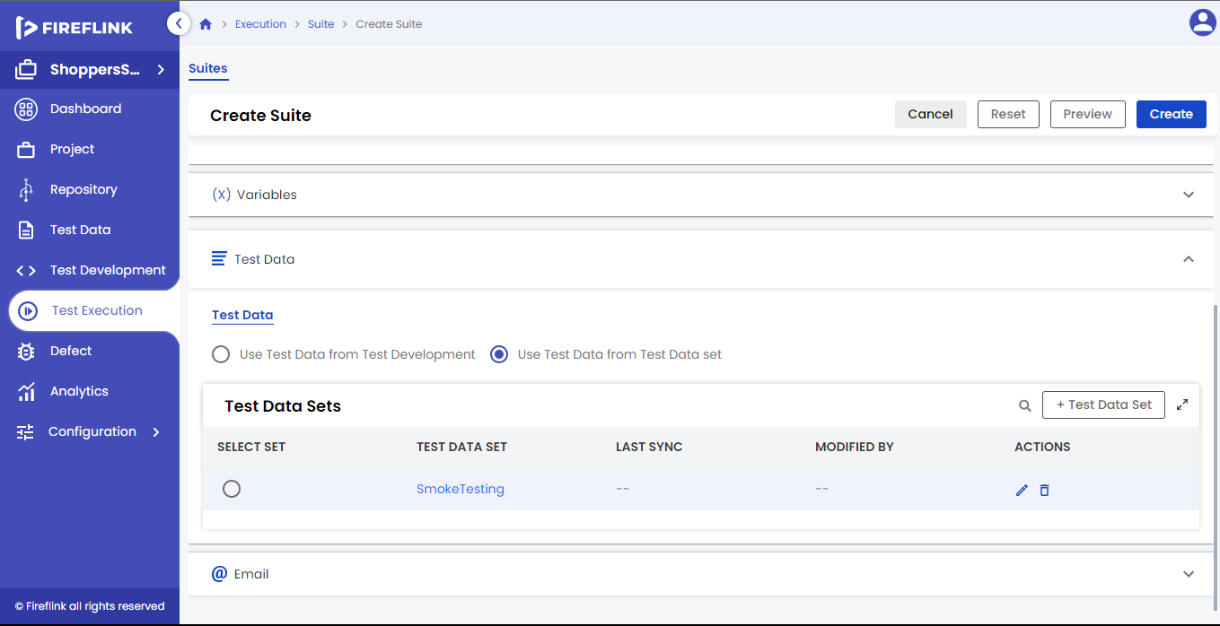

* Mouse hover on a Test Data Set name that you need to Edit.
* Click on the Edit icon.
* Edit Test Data Set popup is prompted.
* Click on the replace icon to replace the test data file.
* Click on the Update button.

**Edit Test Data Set Table:**

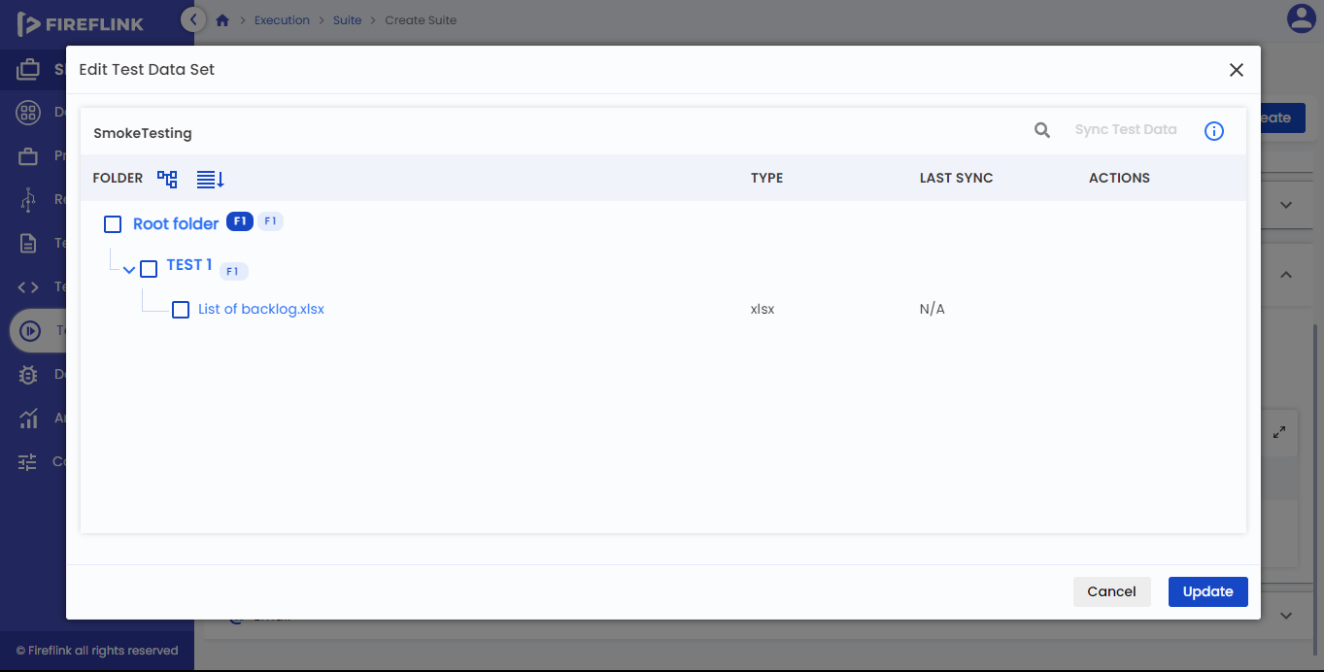

The Test Data Set name table is displayed below the popup header. Columns under Test Data Set Name Table are:-

* **Folder:**
  + This column displays the Test Data folder, Sub Test Data folder, Test Data files, and Root Folder.
  + In the first row of the Folders column, the tree structure icon, and the Scripts icon is displayed in front of the Root folder, and next to the Root Folder number of Folders and number of Files count are displayed.
  + The number of files counted for the Sub-Test Data folder should be the total number of files present in the Sub-Test Data folder.
  + The number of files counted for the Test Data folder should be the total number of files present in the Test Data folder and the number of files present in the subtest data folder.
  + The number of files and folders counted for the Root folder will be the total number of files and folders there in the complete tree structure.
* **Type:**
  + Under this column, the Test Data File type is displayed.
  + The Root folder, Test Data folder, Sub-Test Data folder, and Type column should be empty. But for the Test Data file, based on the file type present, it should display the file type in the “Type” column(Docx, txt, xlsx).
* **Last Sync:**
  + This column displays the Last Sync details for the Test Data set. Here, the last sync details are displayed in this column when all Test Data values are synced in that particular set, otherwise, it displays NA.
* **Actions:**
  + Under this column, the “Download” and “Replace” icons are displayed on mouse hover on the Test Data Set.
  + When a user clicks on the download icon, the test data file should have been downloaded to the local system.
  + When a user clicks on the Replace icon of a particular test data file, the user is navigated to the file explorer of the local system. Users should select the test data file in the local system. After selecting, click on the “select” button to replace the selected file with the existing one.

How to sync test data files in the existing Set?

* Click on the edit icon particularly set which one you want to sync.
* Select the test data file by clicking on the check box after that “Sync test data” button will turn into an enabled state.
* Click on the “Sync test data” button.
* Click on the “Update” button.
* When the user clicks on the “Cancel” button, the “Edit Test Data set” popup is closed and the user is navigated back to the “Test Data set” table.
* When a user clicks on the “Update” button, the Test Data File and synced Test Data File are updated to the Test Data set.

Delete Test Data Set

* Mouse hover on a Test Data Set name that needs to be Deleted.
* Click on the “Delete” icon.
* A warning popup will be prompted.
* Click on the “Delete” button.  
  Note: Based on Impact, the user is allowed to delete the Test Data Set.

4. **Email:** As it is explained in manual suite creation, it follows the same here.

User Settings

* User Settings is nothing but configuring the Settings by selecting the machine to run the suite.
* Once the suite is created, click on the “run” button it will display user settings.

**Why do we need User Settings?**

* Select the machine, browser, and devices and set the Execution environment.
* To set the Implicit and explicit wait time.
* To do Result Settings.
* To set when execution terminates.

**Pre-requisites for User Settings**

* The suite should be selected for user settings.
* Based on selected Modules/Script types, machines should be available.

Run Settings consisted of four tabs in a row below the stepper design, they are:-

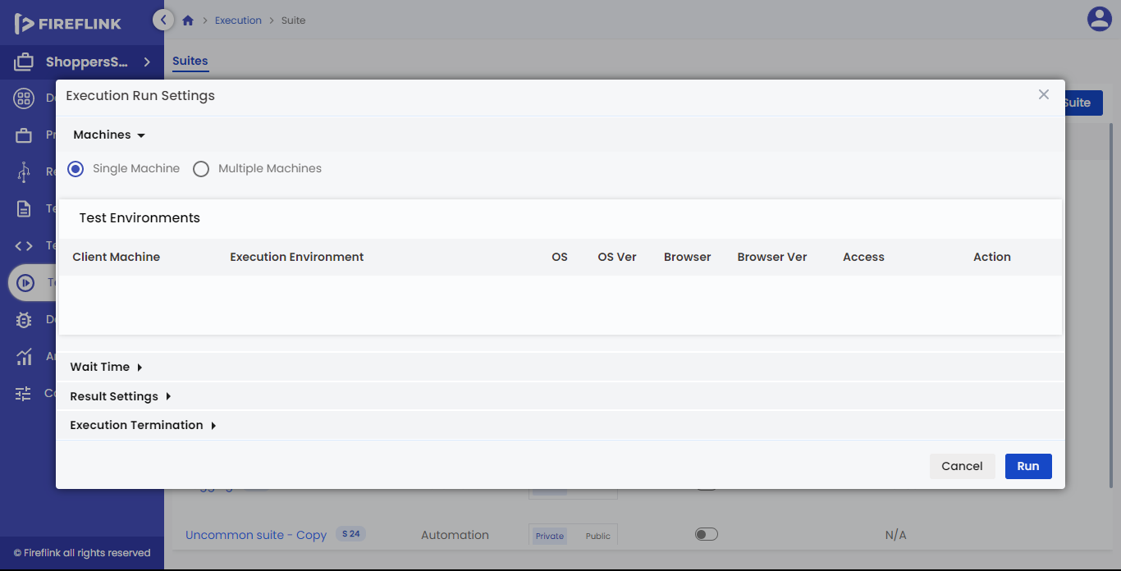

* Machines.
* Wait Time.
* Result Settings.  
  Note: By default, the “Machines” tab will be selected.
* Execution Termination.

**4.1 Machines**

Inside the Machines tab, two radio buttons are present one after the other in a single row below the tab. Based on the execution, the user can choose the radio button. They are:-

* Single Machine – For sequential execution, users should choose this radio button.
* Multiple Machine – For parallel and distributed execution users should choose this radio button.

**4.1.1 Single Machine**

When the user selects the Single-machine radio button, the “Select Machine” button is present below the radio button. The user should click that button to select the machine for execution. Upon clicking on it, the “Test Environments” popup is prompted. The contents of the popup are explained below: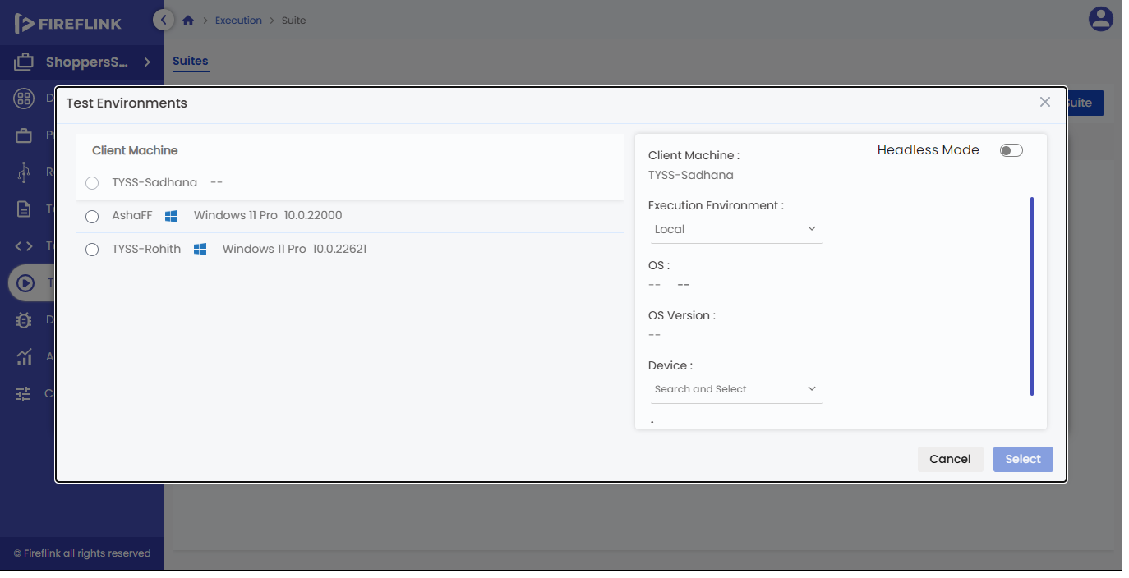

**Test Environments popup.**

* In the “Test Environments” popup, when the user clicks on the “Cross” icon, the “Test Environments” popup is closed,d and the user is navigated back to the Machines tab.

The select Machine table is displayed below the popup header.

**Columns under Select Machine Data Table are:**

* **Radio Button:** This column displays radio buttons for machines. Here, the user can select any one of the machines by selecting a radio button.
* **Headless mode:** A toggle button to execute the web script in the headless modeparallely.
* **Client Machine:** This column displays only suitable client machine names based on the type of script.
* **Execution Environment:**
  + This column displays the Execution Environment drop-down.
  + In the execution environment drop-down, three options are present. They are ‘Local’, ‘Browser Stack’, and ‘Sauce labs’.
  + By default, ‘Local’ is selected in the Execution environment column.
* **OS:** This column displays the operating system icon. The operating system supported by the machine is displayed here.



* **Browser:**
  + This column displays the Browser drop-down.
  + Users can select only those browsers that are present on the particular machine. The selected browser is displayed in this column.
  + For one machine, the user is allowed to select only one browser. Users can select either ‘Chrome’, ‘Internet Explorer, ‘Firefox’, or ‘Microsoft Edge browser.
* **Device:**
  + This column displays the Device drop-down.
  + Users can select only the devices that are present in the particular machine. Selected devices are displayed in this column. Here, users can select more than one device.
  + For one machine, the user is allowed to select only two devices. If the user wants to select one device, the user can choose either Android or iOS. But, if the user wants to select two devices, it should be a combination of Android and iOS. Users are not allowed to select both devices from Android or iOS.
* **Access:**
  + Under this column, Access specifiers are displayed for specific Machines.
  + The Access may be ‘Private’, ‘Public’, or ‘Partial Private’.
* **Status:**
  + This column displays the status of the particular machine.
  + The status may be ‘Available’, ‘Busy’, ‘Disabled’, and ‘Inactive’.
* In the **“Test Environments”** table, by default, only 5 rows are visible on every page. If it contains more than 5 rows it is present on the next page, but that is hidden. Users can see that hidden page by clicking the forward icon in the pagination section.
* When a user clicks on the **“Cancel”** button, the **“Test Environments”** popup is closed without selecting any machines and the user is navigated back to the Machines tab.
* When a user clicks on the **“Select”** button, the **“Test Environments”** popup is closed by selecting the machine, and the user is navigated back to the Machines Tab. The selected machine is displayed in the “Test Environments” table.

How to Select a Machine?

* Click on the **“Select Machine”** button in the Machines tab.
* Test Environments popup will be prompted.
* Select the machine by clicking on the particular machine radio button.
* Click on the **“Select”** button.

**Test Environments Table:**

When the user selects the machine in the “Test Environments” popup, the “Test Environments” table is displayed below the “Single Machine” radio button.

**Columns under the Test Environments Table are: -**



* **Client Machine:** This column displays only suitable client machine names based on the type of script.
* **Headless mode:** A toggle button to execute the web script in the headless parallelly.
* **Execution Environment:**
  + This column displays the Execution Environment drop-down.
  + In the execution environment drop-down, three options are present. They are ‘Local’, ‘Browser Stack’, and ‘Sauce labs’.
  + By default, ‘Local’ is selected in the Execution environment column.
* **OS:** This column displays the operating system icon. The operating system supported by the machine is displayed here.
* **Browser:**
  + This column displays the Browser drop-down.
  + Users can select only those browsers that are present on the particular machine. The selected browser is displayed in this column.
  + For one machine, the user is allowed to select only one browser. Users can select either ‘**Chrome**’, ‘**Internet Explorer**, **‘Firefox’** or **‘Microsoft Edge**browser.
* **Device:**
  + This column displays the Device drop-down.
  + Users can select the devices that are present in the particular machine. Selected devices are displayed in this column. Here, users can select more than one device.
  + For one machine, the user is allowed to select only two devices. If the user wants to select one device, the user can choose either Android or iOS. But, if the user wants to select two devices, it should be a combination of Android and iOS**.** The user is not allowed to select both devices from android or iOS.
* **Access:**
  + Under this column, Access specifiers are displayed for specific Machines.
  + The Access may be **‘Private’, ‘Public’, or ‘Partial Private’**.
* **Status:**
  + This column displays the status of the particular machine.
  + The status may be **‘Available’, ‘Busy’, ‘Disabled’, or ‘Inactive’.**
* **Actions**:
  + Under this column, the **“Replace”** icon will be displayed on the mouse hover on the Machine.
  + When the user clicks on the Replace icon, the Test Environments popup is prompted for machine selection.

How to change the selected Machine?

* Hover the mouse on a Machine name that you need to replace.
* Click on the Replace icon.
* Test Environment pop-up will be prompted.
* Select the machine by clicking on the particular machine radio button.
* Click on the Select button.

**4.1.2 Multiple Machine:**

When the user selects the multiple-machine radio button, the **“Select Execution Type”**Section is displayed below the radio button.

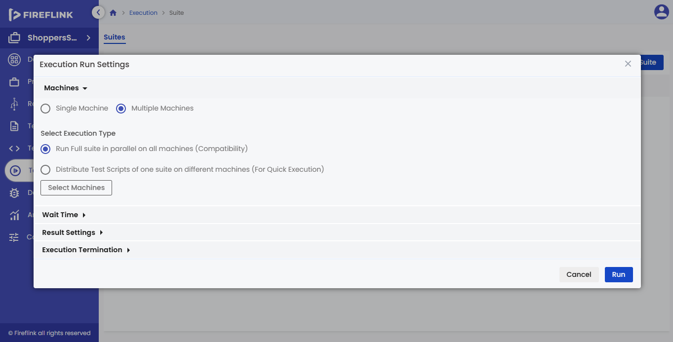

In the **“Select Execution Type”** section, two radio buttons are present. i.e

* Run Full suite in parallel on all machines (Compatibility) – For parallel execution, the user should choose this radio button.
* Distribute Test Scripts of one suite on different machines (For Quick Execution) – for distributed execution, the user should choose this radio button.

**4.1.2.1 Run Full suite in parallel on all machines(Compatibility**)

If the user wants to perform parallel execution, the user should choose this option.

When the user selects this radio button, the “Test Environments” table is present below the Select Execution Type section. The table columns are explained below:



* **Client Machine**: This column displays only suitable client machine names based on the type of script.
* **Headless mode:** A toggle button to execute the web script in the headless mode paralleley.
* **Execution Environment:**
  + This column displays the Execution Environment drop-down.
  + The execution environment dropdown consists of three options. They are ‘Local’, ‘Browser Stack’, and ‘Sauce labs’.
  + By default, ‘Local’ is selected in the Execution environment column.
* **OS:** This column displays the operating system icon. The operating system supported by the machine is displayed in this column.
* **Browser:**
  + This column displays the Browser drop-down.
  + Users can select only those browsers present on the particular machine. The selected browser is displayed in this column.
  + For one machine, the user is allowed to select only one browser. Users can select any one from the below browsers ‘Chrome’, ‘Internet Explorer, ‘Firefox’ or ‘Microsoft Edge.
* **Device:**
  + This column displays the Device drop-down.
  + Users can select the devices that are present in the particular machine. Selected devices are displayed in this column. Here, the user can select more than one device.
  + For one machine, the user is allowed to select only two devices. If the user wants to select one device, the user can choose either Android or iOS. But, if the user wants to select two devices, it should be a combination of Android and iOS. The user is not allowed to select both devices from Android or iOS.
* **Access:**
  + Under this column, Access specifiers are displayed for specific Machines.
  + The Access may be ‘Private’, ‘Public’, or ‘Partial Private’.
* **Status:**
  + This column displays the status of the particular machine.
  + The status may be **‘Available’, ‘Busy’, ‘Disabled’, or ‘Inactive’.**
* **Actions:**
  + Under this column, the **“Delete”** icon is displayed on mouse hover on the Machine.
  + When a user clicks on the **“Delete”** icon, a Warning popup is prompted for deleting the machine.
* When a user clicks on the **“Select Machines”** button, a **“Test Environment”** pop-up is prompted for machine selection.
* To display all the selected machines in complete view, the user should click on the full-screen icon.  
  Note: When there are no machines present in the table, the Full-Screen Icon is in disabled mode.
* In the **“Test Environments”** table, by default, only five rows are visible on each page. If it contains more than five rows it is present on other pages but is hidden. The user can see those hidden pages by clicking on the forward icon in the pagination section.

**Select Machine in Test Environment Table:**

* Click on the “**Select Machines**” button that is present in the Test Environments table.

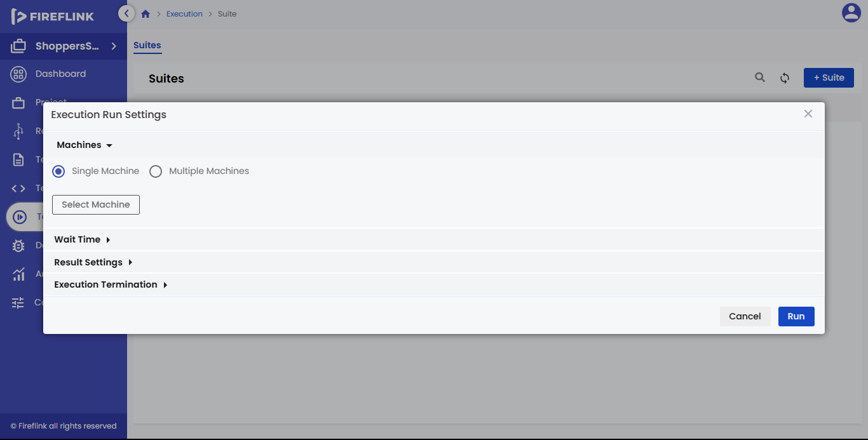

* Test Environments popup is prompted.
* Select the machines’ by clicking on the particular machines’ check boxes.
* Click on the Select button.

How to remove the Selected Machine?

* Mouse hover on a Machine name that needs to be removed.
* Click on the “Delete” icon to remove the machine.

Test Environments popup:

In the**“Test Environments”** popup, when the user clicks on the **“Cross”** icon, the **“Test Environments”** popup is closed and the user will navigate back to the **“Test Environments”** table.

The select Machine table is displayed below the popup header.

Columns under Select Machine Data Table are:-



* **Checkbox:** This column displays radio buttons for machines. Here, the user can select any one of the machines by selecting a radio button.
* **Client Machine:** This column displays only suitable client machine names based on the type of script.
* **Headless mode:** A toggle button to execute the web script in the headless mode paralleley.
* **Execution Environment:**
  + This column displays the Execution Environment drop-down.
  + The execution environment dropdown consists of three options. They are ‘Local’, ‘Browser Stack’, and ‘Sauce labs’.
  + By default, ‘Local’ is selected in the Execution environment column.
* **OS:** This column displays the operating system icon. The operating systems supported by the machine are displayed in this column.
* **Browser:**
  + This column displays the Browser drop-down.
  + Users can select only those browsers present on the particular machine. The selected browser is displayed in this column.
  + For one machine, the user is allowed to select only one browser. Users can select either**‘Chrome’, ‘Internet Explorer, ‘Firefox’, or ‘Microsoft Edge browser’.**
* **Device:**
  + This column displays the Device drop-down.
  + Users can select the devices that are present in the particular machine. Selected devices are displayed in this column. Here, users can select more than one device.
  + For one machine, the user is allowed to select only two devices. If the user wants to select one device, the user can choose either Android or iOS. But, if the user wants to select two devices, it should be a combination of Android and iOS. The user is not allowed to select both devices from Android or iOS.
* **Access:**
  + Under this column, Access specifiers are displayed for specific Machines.
  + The Access may be ‘Private’, ‘Public’, or ‘Partial Private’.
* **Status:**
  + This column displays the status of the particular machine.
  + The status may be ‘Available’, ‘Busy’, ‘Disabled’, or ‘Inactive’.
* In the **“Test Environments”** table, by default, only 10 rows are visible on every page. If it contains more than 10 rows it will be present on the next page but that is hidden. Users can see the hidden page by clicking the forward icon in the pagination section.
* When a user clicks on the **“Cancel”** button, the **“Test Environments”** popup closes without selecting any machines and the user is navigated back to the **“Test Environments”** table.
* When a user clicks on the **“Select”** button, the**“Test Environments”** popup closed by selecting the machine, and the user is navigated back to the **“Test Environments”**table, The selected machine is displayed in the “Test Environments” table.

**4.1.2.2 Distribute Test Scripts of one suite on different machines (For Quick Execution)**

When the user selects Distributed Test Scripts of one suite on the different machines’ radio buttons, the **“Distribution mechanism”** Section is displayed below the radio button.

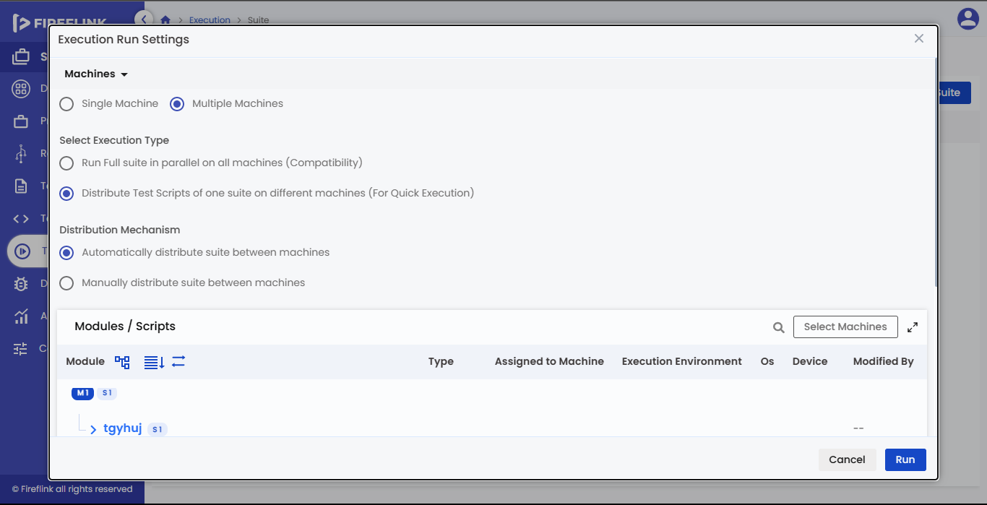

In the **“Distribution mechanism”** section, two radio buttons are present. i.e.

* **Automatically distribute suite between machines** – to distribute the Scripts automatically between the machines, the user should choose the **“Automatically distribute suite between machines”** radio button.
* **Manually distribute suite between machines** – to distribute the Scripts manually between the machines, the user should choose the **“Manually distribute suite between machines”** radio button.

**4.1.2.2.1 Automatically distribute suite between machines**

If the user wishes to perform Automated distributed execution, the user should choose the **“Automatically distribute suite between machines”** option.

When the user selects the **“Automatically distribute suite between machines”** radio button, the **“Modules/Scripts”** table is present below the distribution mechanism section.



**The table columns are explained below:**

* **Module:** Under the module column, the module tree structure will be displayed, and which user is selected in the selected modules/Scripts popup.
* **Type:** Under this column, the Script type is displayed.
* **Assigned to Machine:** This column displays the client machine name which the user selected in the test environment popup.
* **Execution Environment:** This column displays the execution environment which the user selected in the test environment popup.
* **OS:** This column displays the operating system icon which the user selected in the test environment popup.
* **Browser:** This column displays the Browser icon that the user selected in the test environment popup.
* **Modified By**: Under this column modified details are displayed.

**Test Environments Popup:**

In the **“Test Environments”** popup, when the user clicks on the **“X”** icon, the **“Test Environments”** popup is closed and the user will navigate back to the **“Modules/Scripts”** table.

The select Machine table is displayed below the popup header.

Columns under Select Machine Data Table are:-



* **Check Box:** This column displays the Check box for machines. Here, the user can select any number of machines by selecting the check box.
* **Client Machine:** This column displays only client machines’ names based on their project type.
* **Headless mode:** A toggle button to execute the web script in the headless mode parallely.
* **Execution Environment:**
  + This column displays the Execution Environment drop-down.
  + The execution environment dropdown consists of three options. They are ‘Local’, ‘Browser Stack’, and ‘Sauce labs’.
  + By default, ‘Local’ is selected in the Execution environment column.
* **OS:** This column displays the operating system icon. The operating systems supported by the machine are displayed in this column.
* **Browser**:
  + This column displays the Browser drop-down.
  + Users can select only those browsers present on the particular machine. The selected browser is displayed in this column.
  + For one machine, the user is allowed to select only one browser. Users can select either **‘Chrome’, ‘Internet Explorer, ‘Firefox’, or ‘Microsoft Edge** browser.
* **Device:**
  + This column displays the Device drop-down.
  + Users can select the devices that are present in the particular machine. Selected devices are displayed in this column. Here, users can select more than one device.
  + For one machine, the user is allowed to select only two devices. If the user wants to select one device, the user can choose either Android or iOS. But, if the user wants to select two devices, it should be a combination of Android and iOS. The user is not allowed to select both devices from Android or iOS
* **Access:**
  + Under this column, Access specifiers are displayed for specific Machines.
  + The Access may be ‘Private’, ‘Public’, or ‘Partial Private’.
* **Status:**
  + This column displays the status of the particular machine.
  + The status may be **‘Available’, ‘Busy’, ‘Disabled’, or ‘Inactive’**.
* In the **“Test Environments”** table, by default, only 5 rows are visible on every page. If it contains more than 5 rows it will be present on the next page but that is hidden. Users can see that hidden page by clicking the forward icon in the pagination section.
* When a user clicks on the “Cancel” button, the “Test Environments” popup closes without selecting any machines and the user is navigated back to the “Modules/Scripts” table.
* When a user clicks on the **“Select”** button, the**“Test Environments”** popup closed by selecting the machine, and the user is navigated back to the “Modules/Scripts” table. The selected machine is displayed in the “Modules/Scripts” table.

Select Machine in Test Environment Table:

* Click on the **“Select Machines”** button that is present in the Test Environments table.
* Test Environments popup is prompted.
* Select the machines by clicking on the particular machine’s checkboxes.
* Click on the Select button.
* Scripts will be automatically distributed between the machines.
* The assigned machine will be displayed in the modules/Scripts table

**4.1.2.2.2 Manually distribute suite between machines**

If the user wants to perform Manual distributed execution, the user should choose this option.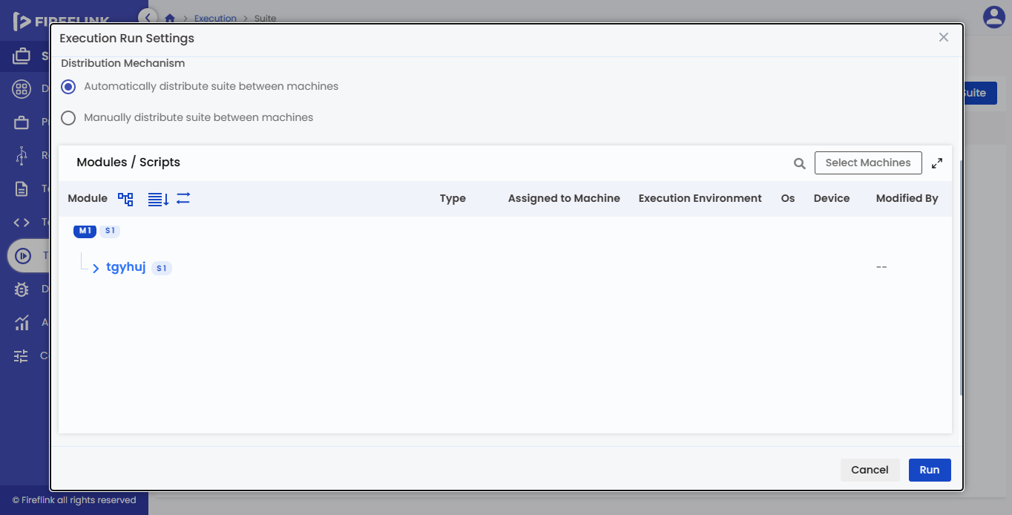

When the user selects this radio button, the **“Modules/Scripts”** table is present below the distribution mechanism section.



The table columns are explained below:

* **Module:** Under this column module tree structure will be displayed, which user is selected in the select modules/Scripts popup.
* **Type:** Under this column, the Script type is displayed.
* **Assigned to Machine:** This column displays the client machine name which the user selected in the test environment popup.
* **Headless mode:** A toggle button to execute the web script in the headless mode parallely.
* **Execution Environment:** This column displays the execution environment which the user selected in the test environment popup.
* **OS:** This column displays the operating system icon which the user selected in the test environment popup.
* **Browser:** This column displays the Browser icon that the user selected in the test environment popup.
* **Modified By:** Under this column modified details are displayed.

Select Machine in Test Environment Table:

* Select the module checkbox in the modules/Scripts table.
* Click on the **“Select Machine”** button that is present in the Modules/Scripts table.
* Test Environments popup is prompted.
* Select the machines by clicking on the particular machine’s radio button.
* Click on the Select button.

**Test Environments Popup:**

In the **“Test Environments”** popup, when the user clicks on the **“X”** icon, the **“Test Environments”** popup is closed and the user will navigate back to the **“Modules/Scripts”** table.

The select Machine table is displayed below the popup header.

Columns under Select Machine Table are:-



* **Radio Button:** This column displays radio buttons for machines. Here, the user can select any one of the machines by selecting a radio button.
* **Client Machine:** This column displays only client machines’ names based on project type.
* **Headless mode:** A toggle button to execute the web script in the headless mode parallely.
* **Execution Environment:**
  + This column displays the Execution Environment drop-down.
  + The execution environment dropdown consists of three options. They are **‘Local’, ‘Browser Stack’, and ‘Sauce labs’.**
  + By default, ‘Local’ is selected in the Execution environment column.
* **OS:** This column displays the operating system icon. The operating systems supported by the machine are displayed in this column.
* **Browser:**
  + This column displays the Browser drop-down.
  + Users can select only those browsers present on the particular machine. The selected browser is displayed in this column.
  + For one machine, the user is allowed to select only one browser. Users can select either ‘Chrome’, ‘Internet Explorer, ‘Firefox’, or ‘Microsoft Edge browser.
* **Device:**
  + This column displays the Device drop-down.
  + Users can select the devices that are present in the particular machine. Selected devices are displayed in this column. Here, the user can select more than one device.
  + For one machine, the user is allowed to select only two devices. If the user wants to select one device, the user can choose either Android or iOS. But, if the user wants to select two devices, it should be a combination of Android and iOS. The user is not allowed to select both devices from Android or iOS.
* **Access:**
  + Under this column, Access specifiers are displayed for specific Machines.
  + The Access may be **‘Private’, ‘Public’, or partially Private’**.
* **Status:**
  + This column displays the status of the particular machine.
* The status may be ‘Available’, ‘Busy’, ‘Disabled’ or ‘Inactive’
* In the **“Test Environments”** table, by default, only 5 rows are visible on every page. If it contains more than 5 rows it will be on the next page but it will be hidden. Users can see the hidden page by clicking the forward icon in the pagination section.
* When a user clicks on the **“Cancel”** button, the **“Test Environment”** popup closes without selecting any machines and the user will be navigated back to the **“Modules/Scripts”** table.
* When a user clicks on the **“Select”** button, the **“Test Environments”** popup closed by selecting the machine, and the user will be navigated back to the **“Modules/Scripts”** table. The selected machine is displayed in the **“Modules/Scripts”** table.

How to change the selected Machine for a module?

* Select the module checkbox in the modules/Scripts table that you need to replace.
* Click on the **“Select Machine”** button that is present in the Modules/Scripts table.
* Test Environments popup is prompted.
* Select the machines by clicking on the particular machine’s radio button.
* Click on the “Select” button.

How to execute the suite in sequential order?

* In the User Settings section, click on the machines tab and select the “Single Machine” radio button.
* Click on the “Select Machine” button.
* Test Environments popup is prompted.
* Select the suitable machine for the execution by clicking on the radio button.
* Select the required execution type, browser, headless mode and devices for the machine.
* Click on the select button.

How to execute the suite in parallel?

* In the User Settings section, click on the machines tab and select the **“Multiple Machines”** radio button.
* Select the “Run Full suite in parallel on all machines(compatibility)” radio button in the “Select Execution Type” section.
* Click on the “Select Machines” button in the Test Environments table.
* Test Environments popup will be prompted.
* Select the suitable machines for execution by clicking the checkboxes.
* Select the required execution type, browser, headless mode and devices for the machine.
* Click on the select button

How to execute the Automatically distributed Suite?

* In the User Settings section, click on the machines tab and select the “Multiple Machines” radio button.
* Select the “Distribute Test Scripts of one suite on different machines (For Quick Execution)” radio button in the “Select Execution Type” section.
* Select the “Automatically distribute suite between machines” radio button in the “Distribution Mechanism” section.
* Click on the “Select Machines” button in the Modules/Scripts table.
* Test Environments popup will be prompted.
* Select the machines by clicking on the particular machine’s checkboxes.
* Select the required execution type, browser, headless mode and devices for the machine.
* Click on the Select button.
* Scripts will be automatically distributed between the machines.

How to execute the Manually distributed Suite?

* In the User Settings section, click on the machines tab and select the **“Multiple Machines”** radio button.
* Select the “Distribute Test Scripts of one suite on different machines (For Quick Execution)” radio button in the **“Select Execution Type”** section.
* Select the **“Manually distribute suite between machines”** radio button in the **“Distribution Mechanism”** section.
* Select the Module by clicking on the checkbox.
* Click on the **“Select Machines”** button in the Modules/Scripts table.
* Test Environments popup will be prompted.
* Select the machines by clicking on the particular machine’s checkboxes.
* Select the required execution type, browser, headless mode and devices for the machine.
* Click on the Select button.
* Scripts will be automatically distributed between the machines.

**4.2 Wait Time**

Inside the Wait Time tab, three mandatory fields are present one after the other. They are: -

* Implicit Wait
* Explicit Wait
* Delay Between Steps

**4.2.1 Implicit Wait**

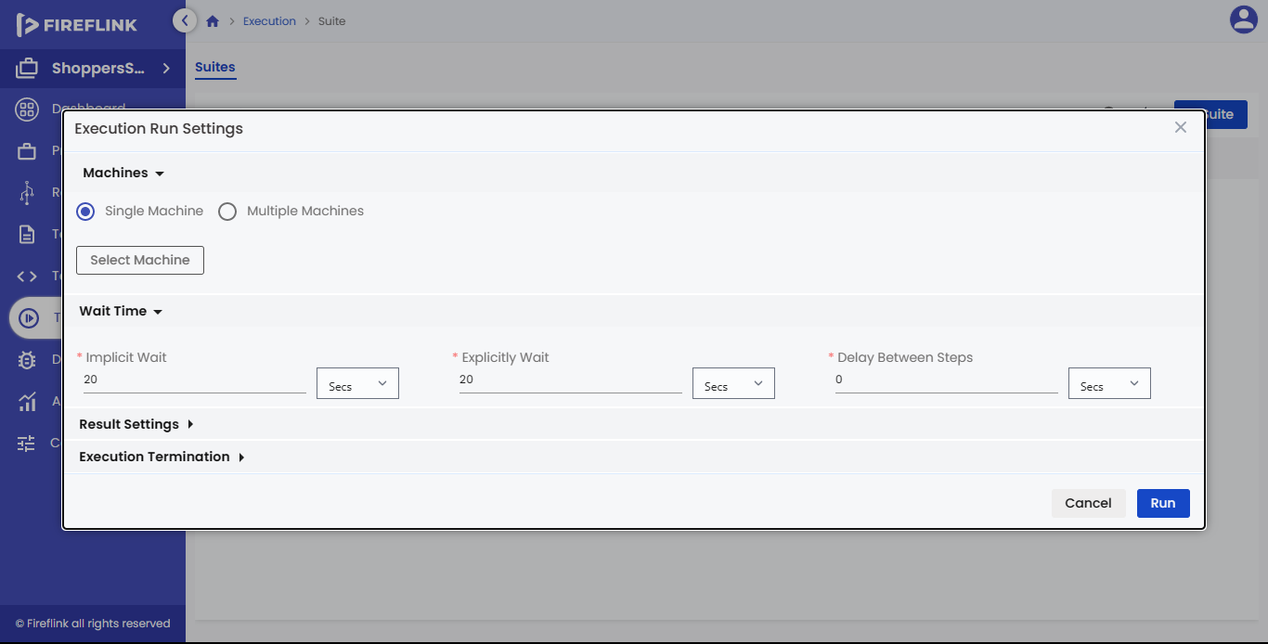

Users can enter the required value in the field. Here, the user is not allowed to change the time unit.

Users can increase or decrease the entered value by clicking the up or down arrow.

By using Implicit wait, if you want to click on the element, the driver will not wait entirely until the given time, it performs the action as soon as it finds the element.

**4.2.2 Explicit Wait**

Users can enter the required value in the field. Here, the user is not allowed to change the time unit.

Users can increase or decrease the entered value by clicking the up or down arrow.

By using Explicit wait, If you want to click on the element, the driver will wait until the given condition is satisfied, and then it will perform the next action.

**4.2.3 Delay Between Steps**

Users can enter the required value in the field. Here, the user is not allowed to change the time unit.

Users can increase or decrease the entered time by clicking the up or down arrow.

By using Delay Between Steps, after the execution of the step Web Driver is directed to wait for a certain period of time before proceeding with the next step execution.

**4.3 Result Settings**

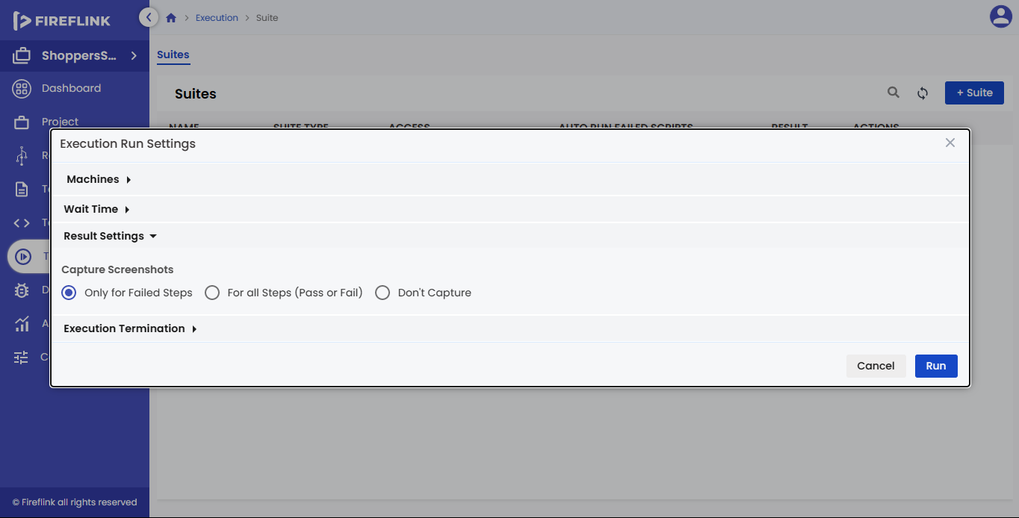

Inside the Result Settings tab, one section is present one below the other. They are: -

* Capture Screenshots

**4.3.1 Capture Screenshots**

In this section, there are three radio buttons in a single row. Based on the selection of the radio button it will capture screenshots (Refer to the above screen).

* Only for Failed Steps: When the user selects this radio button, Screenshots are captured when the execution failed. It will also notify the user when the memory is full. Old screenshots are replaced by new screenshots.
* For all Steps (Pass or Fail): When the user selects this radio button, Screenshots are captured for all steps of execution, either pass or fail. It will notify the user when the memory is full. Old screenshots are replaced by new screenshots.
* Don’t Capture: When the user selects this radio button, Screenshots are not captured for execution, either it is pass or fails.  
  Note: By default, the “Only for Failed Steps” radio button is selected.

**4.4** **Execution Termination**

Inside the execution termination tab, two sections are present one below the other.

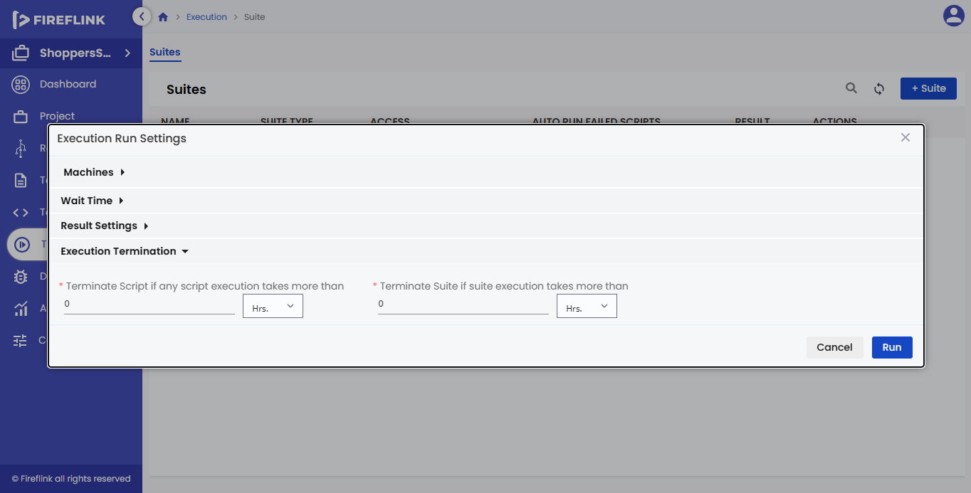They are: -

* Terminate Script if any script execution takes more than: When the user is given a time input in hours or minutes or seconds, based on that if any Script execution takes more time than the specified time it will terminate the execution automatically.
* Terminate Suite if any suite execution takes more than: When a user is given a time input in hours or minutes or seconds, based on that if any suite execution takes more time than the specified time it will terminate the execution automatically.